Measuring What Ownership Means: Cross-Country Validation of MAGNET Tools on Asset Rights, Control, and Preferences

Ardina Hasanbasri (Yale University)
Heather Moylan (The World Bank Group)
Cheryl Doss (Tufts University)
Maria Hernandez De Benito (University of Alicante)
Marya Hillesland (Oxford University)

Abstract
Research has shown that ownership of assets, such as land, is strongly correlated with well-being and economic security. To understand this relationship, robust measures of ownership are needed. However, standard survey modules on asset ownership often rely on a single respondent and capture only reported or documented ownership. To address this limitation and to better understand ownership and the effects on women’s empowerment, the Measures for Advancing Gender Equality (MAGNET) Initiative developed five survey tools - vignettes and a scale - to address key questions such as: What does ownership entail? Do people share a common understanding of ownership? What are people’s preferences regarding individual versus joint ownership? Each tool was tested in the field in at least two countries per tool covering land and other key assets. This paper validates the tools using a three-phase framework and motivates their inclusion in household surveys.

- Introduction
Researchers have linked expansion of women’s control over assets with promoting economic development and wellbeing (O’Sullivan 2017; Doss, Kieran, and Kilic 2019). Evidence of improvements have been found for several socioeconomic outcomes such as greater female bargaining and decision-making power (Fafchamps and Quisumbing 2002; Melesse, Dabissa, and Bulte 2018; Meinzen-Dick et al. 2019; Mookerjee 2019), reduction in domestic violence (Amaral 2017; Peterman et al. 2017), increased consumption and human capital investments (Muchomba 2017; Harari 2019; Calvi 2020; Milazzo and Van de Walle 2021), improved children’s nutrition and human capital (Allendorf 2007; van der Meulen Rodgers and Kassens 2018; Deininger et al. 2019), and reduced child marriage rates (Muchomba 2021).
Given this evidence, several advances have been made in methodologies of measuring ownership including project collaborations with researchers of various institutions and international organizations. The Gender Asset Gap Project that started in 2009, for example, aims to demonstrate the importance and feasibility of measuring asset gaps in Ghana, Ecuador, and India (Doss et al. 2011). As part of the United Nations Evidence and Data for Gender Equality Initiative (UN EDGE), the Methodological Experiment on Measuring Asset Ownership from a Gender Perspective (MEXA) provided experimental evidence on the importance of measuring asset ownership at the individual-level and ensuring that the information is self-reported (Kilic and Moylan 2016). Additional research highlighting that different dimensions of rights may not be held by the same person has sparked the inclusion of a range of rights and decision-making questions in household surveys such as document ownership, reported ownership, rights to sell, rights to bequeath, right to use asset as collateral, among others (Doss et al. 2015, Doss et al. 2019, Slavchevska et al. 2020). These projects and discussions have been influential and drove their inclusion in the UN EDGE Guidelines on Asset Ownership, the guidance for the measurement of SDGs on land, and the Living Standard Measurement Study Plus (LSMS+) project, among other initiatives. With new methodologies and increased availability of data on individual asset ownership, researchers and policymakers have been able to make advances in measurement and understanding ownership.
Despite this progress, many open questions remain that standard household survey modules, even at the individual level, cannot answer. When individuals report being an owner, what does “ownership” entail? Do people have the same understanding and interpretation of what ownership means? How do aspects of control and rights vary by characteristics of the assets (type of assets or divisibility) or societal norms (perception of who gets the assets upon divorce, structure of the households, norms concerning gifts and inheritance)? What are people’s preferences regarding individual vs. joint ownership?
To address this limitation and to better measure ownership and understand the effects on women’s empowerment, the Measures for Advancing Gender Equality (MAGNET) Initiative developed five tools related to asset ownership and control – four vignettes and one scale. The MAGNET initiative is a collaborative effort between research teams from several international organizations and universities with the goal of improving our understanding and measurement of women’s agency, including through ownership and control over assets. The MAGNET team designed and piloted each tool in at least two countries covering several different asset classes.

The five tools capture how survey respondents evaluate issues of asset ownership. Tool 1 Preferences over Joint vs. Individual Asset Rights can be used to elicit preferences of whether an individual would prefer to own half of the household assets individually or own them all jointly. In several countries, it has been documented that survey respondents answered that assets can be owned jointly between members of the household (Deere et al. 2012, Doss et al. 2015, Kieran et al. 2015, Hasanbasri et al. 2021). However, there is little evidence on whether individuals would prefer to own assets individually or jointly with their spouse or others.

Tool 2 Asset Rights Upon Marriage Dissolution can be used to elicit opinions on how assets should be divided upon divorce. The literature that uses asset ownership as a measure of bargaining power implicitly assumes that the individual will continue to own it and will thus affect the person’s outside options. The literature is limited in how well the response of "owning jointly" or "exclusively" correlates to a person's ability to retain the asset upon divorce.

The last three tools all explore whether there is variation in access, ownership and control over assets within the community across different types of assets. Tool 3 Understanding the Meanings of Ownership solicits information on this issue by using a vignette that describes a woman purchasing livestock with her own earnings and then explores whether she individually has the right to sell it or whether other members of her household hold some of the rights. Tool 4 Rights when Land is Owned Jointly explores whether permission to sell is needed depending on the mode of acquisition (a couple purchased the land together versus inherited by one of the spouses). Lastly, Tool 5 Control and Benefits Over Assets Scale, elicits information from respondents on the extent to which they control an asset and obtain the benefits from it. This moves us beyond simply thinking about ownership and explores whether respondents have claims over assets, even when they do not own them.

The five tools above provide a means to better understand issues around asset ownership in a particular context. This paper validates the five tools and synthesizes key findings from the pilot data. The validation approach consists of three phases. First, the MAGNET team, drawing on its expertise in asset ownership and women’s agency, led the design of the tools, and the drafts were refined through feedback from external experts. Second, pilot surveys and cognitive interviews were carried out in two countries each, with tools refined based on insights from the pilots. Third, the data from the pilots were analyzed to compare responses across assets, versions, countries, sub-populations.

The remainder of the paper is structured as follows. Section 2 describes our approach to designing the tools and outlines the validation framework used. Section 3 introduces the surveys where the tools were piloted and describes the data. Section 4 presents key findings from each of the tools and considers the associated policy recommendations. Section 5 concludes by synthesizing cross-tool findings and provides recommendations for integrating these tools into other survey efforts.

- Development of Tools and Approach to Validation
2.1 Overview of Tool Types
The MAGNET tools were developed for inclusion in surveys measuring asset ownership and control, whether in large-scale, nationally representative, multi-topic surveys or smaller scale impact evaluations and studies. To justify their inclusion in such surveys, we must demonstrate that the tools reliably measure the intended outcomes. There are two types of tools, vignettes and scales, and each require a distinct validation approach.
2.1.1 Validating Vignettes
The first four MAGNET asset tools are vignettes and involve short, descriptive scenarios designed to elicit respondents’ opinions, beliefs, or attitudes about hypothetical situations. Vignettes are suitable for the measurement of concepts that may be difficult to define and have been used to measure a range of topics including other aspects of women’s economic empowerment (see Bernard et al. 2020, Donald et al. 2020, Masset 2015). Vignettes were deemed the most appropriate data collection method to investigate the key questions for the first four tools. When interviewers ask about preferences on sensitive subject matters, vignettes can be a better option rather than asking directly (Samek 2021). In the case of the MAGNET asset tools, respondents may be uncomfortable reporting hypothetical scenarios about themselves that may be culturally unacceptable such as divorce. It also allows respondents to consider the reality in their country as a whole and the social norms that dictate different concepts. To our knowledge, the asset-related vignettes developed under the MAGNET initiative are the first of their kind designed to deepen our understanding of the complexities of asset ownership and control especially in settings with low levels of formal ownership and scant research on preferences.
In line with the literature on leveraging vignettes in social science research and measurement (see for example, Malapit et al. 2019, Samek et al. 2022), the team followed a rigorous process in developing the tools and focus on assessing three types of validity - content, face, and construct. Content validity refers to how appropriate survey vignettes are for measuring their outcome of interest while face validity refers to the extent to which they cover the concept they intend to measure (Clingain et al 2025). There are no existing statistical methods for assessing content and face validity, but studies recommend relying on subject matter experts (Marie et al. 2021; Randhawa et al., 2015; Paddam et al., 2010). Construct validity considers how well vignettes simulate a real-life scenario (Evan’s et al. 2015) and following the approach used in Clingain et al. 2025 can be assessed through correlations of each measure with different household and individual characteristics that are hypothesized to be correlated based on literature.
2.1.2 Validating Scales
The fifth tool is a scale that aims to simplify the process of collecting information on ownership and control of different types of assets using a Likert scale. We assess the validity of this tool by assessing its content, face, and construct validity like vignettes. Additionally, we assess its structural validity, and internal reliability to evaluate the consistency across scale items following the framework of the vignette validation approach above, the psychometric literature, and the validation process used for scales developed as part of the other two MAGNET pillars (Clingain et al. 2025). This includes analysis to assess the structural validity by conducting confirmatory factor analysis as well as internal reliability through the computation of Cronback’s alpha measuring the degree of correlation among the items of the scale.

2.2 Detailed Description of Iterative Process of Design and Validation
To evaluate these different types of validity, the MAGNET team used an iterative three-phase approach.
2.2.1 Phase I
Phase I consists of the development of the tools by MAGNET researchers and the effort of the team in consulting other experts outside of MAGNET to ensure content and face validity.
The MAGNET researchers who designed the tools have experience developing innovative methods to highlight gender issues. The MAGNET researchers have been collaborating on methods and research on women’s asset ownership for the last 15 years and have a strong record of producing impactful evidence on the topic, both individually and jointly. Within the assets pillar, the work of the researchers has included quantifying the magnitude of gender disparities in asset ownership and wealth and detailing the importance of women’s control over assets for their well-being and that of their households. These researchers are uniquely suited to lead the tool development also thanks to their direct involvement and leadership of the formative projects such as the Gender Asset Gap project, MEXA, LSMS+, and others.
In 2017 the MAGNET researchers carried out a review of the literature on women’s ownership and control over assets, identifying an initial set of knowledge gaps to be addressed through the measurement experiments planned as part of the initiative. Following the desk review on key outstanding research questions related to asset ownership and control it was determined that as part of the MAGNET initiative the team would design and test different vignettes to deepen our understanding of what joint ownership of assets entails (e.g., legal rights, use rights, tenure security, preferences over type of ownership) and of women’s control over resources and the tools were developed. Seeking feedback from external experts was critical with multiple interactive workshops held involving gender and data experts from a variety of research institutions and development institutions.
2.2.2 Phase II
Phase II involved piloting the tools in selected countries accompanied by cognitive interviews to further validate the tools. The local understanding of ownership of different types of assets varies widely, and is affected by institutional settings, markets, norms, and culture of a local area. It was important to pilot the tools in settings reflecting this variation. We also sought to implement these tools in surveys that already included modules soliciting information on individual’s ownership of the asset(s) in question.
In-depth cognitive interviews were carried out prior to conducting the pilot exercises in Kenya and Malawi, in a subset of enumeration areas. Cognitive interviewing was a critical step in the development of these tools because it sought to assess participants’ understanding of survey questions. Following cognitive interviews, the instruments were then revised. Additionally, each country held training of enumerators involving field practices allowing for further refinement of the tools before the start of fieldwork. Across countries, emphasis was placed on the sensitivity of questions on ownership and control and the importance of interviewing respondents in a confidential setting.
Additionally, we also asked respondents: “How clear did you find the phrasing of the preceding question? 1=Very unclear and difficult to answer 2=Slightly unclear and slightly difficult to answer 3=Clear and simple to answer” to gauge comprehension. The inclusion of this question helped to ensure that most respondents understood the scenarios presented. We generally deem a question clear if more than 75% of respondents report “clear and simple to answer” and this was achieved across all asset tools.

2.2.3 Phase III
The third phase is the analysis of data from the pilot countries and evaluates content, structural, and internal validity. To confirm content validity, the analysis of the tools examines the versions tested, compares results both within and across-country, considers the association of the outcomes of interest with a series of covariates, and ensures that respondents report comprehension of the tool contents. For the scale, we also perform exploratory factor analysis and compute Cronbach’s alpha to ensure structural validity and internal reliability. Results from the third phase comprise the remainder of this paper.
- Data Description
In Kenya, the MAGNET tools were implemented in Kilifi County, as part of a REACH-funded survey on water collection, access, and use and how these interrelates to household decision-making dynamics including control over assets, productive opportunities, and livelihoods. The person who was responsible for the household water portfolio was asked questions about the household overall; all adult household members were asked a set of questions individually about their own experiences.
In Malawi, the MAGNET tools were implemented as part of the LSMS Methodological Experiment on Time Use Measurement in 72 enumeration areas in urban and rural areas. One adult man and one adult woman (aged 15-64) were selected from each household as respondents and teams were trained to administer individual level modules to the selected respondents simultaneously to the extent possible.
In Tanzania, the MAGNET tools were conducted as part of the Tanzania Household Consumption Methodology Study. The respondents were largely women since the guidance was to interview the household member responsible for food purchases and preparations.

In Cote d’Ivoire, the MAGNET tools were implemented as part of a randomized control trial that explored the link between worker networks and labor complementarity. The sample of 578 respondents is quite different compared to samples from other countries because it focused on younger urban blue-collar workers.
In India, MAGNET implemented a survey in four districts of Karnataka, interviewing 956 women and 867 men aged 18 to 77 years old in both urban and rural areas.
In Uganda, MAGNET implemented a survey in the Kayunga and Mukono districts, which have diverse agriculture and business-oriented livelihoods. The sample comprised 1,123 women and 889 men aged 17-86.

- Assets Tools and Validation Results

  - Tool 1 Preferences over Joint vs. Individual Asset Rights
4.1.1 Motivation and Design
Individual-level surveys on asset ownership have increasingly collected information on whether respondents hold joint or exclusive ownership over an asset. There is often an implicit assumption that individual ownership is better, and potentially more empowering, than joint ownership. However, existing data provide limited insights as to respondent preference for joint versus exclusive ownership.
Tool 1 aims to fill this gap and elicits responses regarding subjective assessments of the well-being of a hypothetical married individual based on whether they own and/or manage assets individuals or jointly. owning an asset and what type of ownership structure the person would prefer. Versions of the tool varying both the type of asset as well as the division of assets were tested in Cote d’Ivoire, India, Kenya, Malawi and Tanzania.

All pilot countries asked about land, though the amount of land allocated jointly varied by country. In Tanzania and Malawi, respondents were asked if a split of 0.5 acre for the wife and 0.5 acre for the husband is preferred by the wife rather than owning the land jointly. In Kenya and India, a series of questions were asked, but the first one asked about the split of 0.75 for the husband and 0.25 for the wife. In Cote d’Ivoire, respondents were asked regarding the allocation of four acres of land: comparing a split of two and two with jointly owning four or a split of three for the man and one for the woman with jointly owning all four. Cote d’Ivoire also included questions on preferences regarding owning livestock (five goats).
Figure 1. Tool 1
Example with agricultural land
ENUMERATOR READ: I will present a scenario to you about a married couple that owns agricultural land and then ask you a question. There is no right or wrong answer. We are interested in your opinion.
Peter (man) and Grace (woman) are married. Peter is the husband, and Grace is the wife.
NOTE TO ENUMERATOR: Be sure it is clear to the respondent that the following questions are about Peter and Grace and not about the respondent. Also, the focus should be on which land options Grace would find more desirable (and not the relationship between the spouses).
Scenario 1: Peter and Grace own one plot of agricultural land together that is two acres. They own it jointly.
Scenario 2: Peter has a plot of agricultural land that is owned exclusively by him. It is 1 acre. Grace has a plot of agricultural land that is owned exclusively by her. It is 1 acre. Both plots are of equal quality.
All plots are of equal quality.
1. | Which scenario do you think would be most desirable to Grace? | 1 = Scenario 1  2 = Scenario 2  3 = Grace is indifferent between 1 and 2
ENUMERATOR READ: I will present a scenario to you on a married couple that owns agricultural land. In this scenario, “managing” refers to decision-making over any or all the following activities: crops to be planted, input use, timing of cropping activities, use of crop output, earnings from potential crop sales, or other decisions over crop agriculture. There is no right or wrong answer. We are interested in your opinion.
Peter (man) and Grace (woman) are married. Peter is the husband, and Grace is the wife.
Scenario 1: Peter and Grace own one plot of agricultural land together that is 2 acres. They own it jointly and manage it together.
Scenario 2: Peter has a plot of agricultural land that he owns exclusively and is solely responsible for managing. It is 1 acre. Grace has a plot of agricultural land that she owns exclusively and is solely responsible for managing. It is 1 acre. Both plots are of equal quality.
All plots are of equal quality.
2. | Which scenario do you think would be most desirable to Grace? | 1 = Scenario 1  2 = Scenario 2  3 = Grace is indifferent between 1 and 2

4.1.2. Key Results
In four out of the five countries, the majority of respondents, both male and female, answer that joint ownership would be preferred by the wife given the allocation decision that they had to make. The percentage of respondents choosing joint ownership is the highest in India with 90.2%, followed by 80.4% in Kenya, 76.7% in Tanzania, and 66% in Malawi. Cote d’Ivoire is the exception where the majority would not prefer joint ownership. Only 34.1% answered that joint ownership of 4 plots is preferred over exclusive ownership of 2 plots each. When asked about 3 plots for the husband and 1 plot for the wife, more individuals answered that joint is preferred. Gender differences in answers were not statistically significant with the only exception in Cote d’Ivoire for 4 plots jointly or 2 plots exclusively each.

Figure 2. Share Assuming a Woman Prefers Joint Ownership (%)

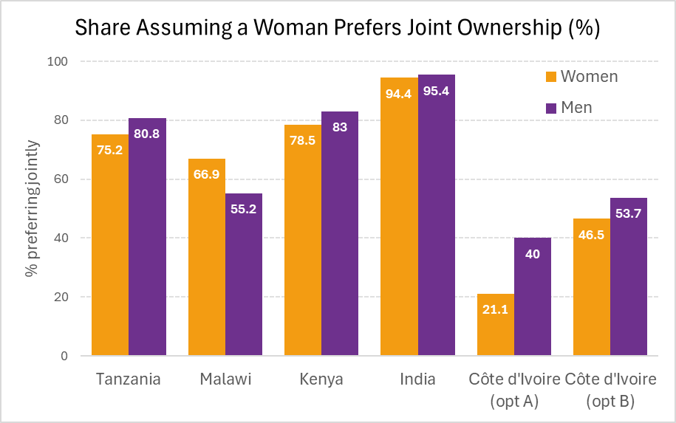

In Cote d’Ivoire, we also asked respondents whether a woman would be better off owning livestock exclusively or owning them jointly with others. Statistically significant gender differences are observed in those responding that joint is preferred by wife. When the wife was offered more goats than the husband exclusively (3 goats), fewer people answered that she would prefer joint relative to if the wife was just offered 2 goats for exclusive ownership. This is consistent with the gender differences in responses regarding landownership in Cote d’Ivoire.
Figure 3 Livestock – Cote d’Ivoire
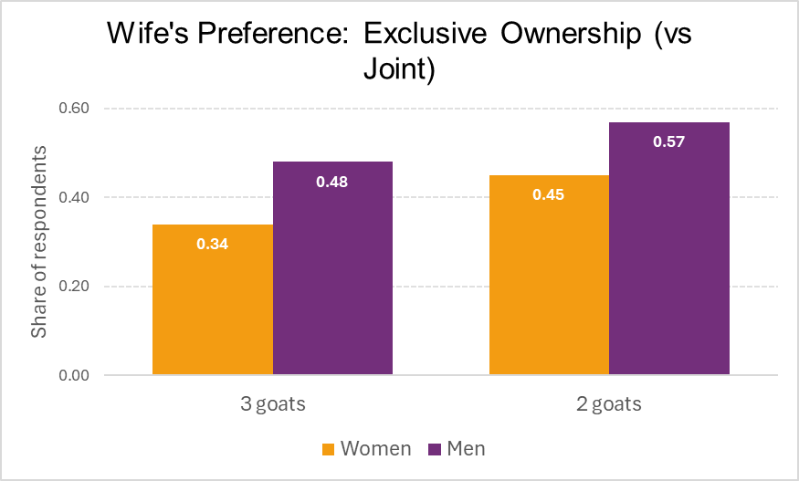

We conduct a regression analysis (a linear probability model) by gender to understand which variables correlate with an individual answering that joint ownership is preferred by the wife. Across countries we found that correlates vary by gender and context with education, and employment standing out as significant predictors.

4.1.3. Tool 1 Summary and Recommendations
Based on the analysis from the pilot countries, researchers and policymakers should not assume that women want to own assets individually rather than jointly. Our analysis reveals that across the pilot countries the majority of respondents believe wives prefer joint ownership, though the share of those preferring joint ownership varies by country. In the Urban sales worker sample in Cote d’Ivoire, those answering joint ownership is preferred was much less. One additional nuance to keep in mind is the difference between “preferring” an arrangement versus benefiting from an arrangement. The questions use the word “preference”, but it is not clear whether this necessarily means the individuals are better off.
Tool 1 may be relevant for practitioners to understand preferences within a particular context. Before allocating assets, such as land or livestock, exclusively to women, it would be important to understand whether they would prefer to own the asset jointly. And understanding men’s responses may help to identify whether there would be backlash against programs granting women assets. Our analysis, however, also revealed that the response to questions in Tool 1 varies by the type of assets and how the assets would be divided if owned exclusively. The inclusion of the option “indifferent” might be informative. About 7% of women in Tanzania and 9% of women in Malawi choose this option when asked about ownership. It is unclear whether this indicates that joint versus exclusive property regimes do not imply any difference in how the plot is controlled or managed, whether the two options have similar net benefits, or whether the respondent is not informed on how the two regimes differ. A follow-up question on those answering “indifferent” could provide additional context.

  - Tool 2 Asset Rights Upon Marriage Dissolution
4.2.1. Tool Motivation and Design
Both the laws and the social norms within a community will influence how resources are allocated in the event of a divorce. In Tool 2, the respondent is given various scenarios about a hypothetical couple that either own 3 goats, 1 cow, a plot of land, or a house. First, the respondent is asked how asset(s) that they jointly purchased after they were married would be divided if the marriage dissolves. Then, the respondent was asked the same question but with variations on how the asset was acquired. This tool was tested in Cote d’Ivoire, India, and Kenya.
Figure 4. Tool 2
READ: Kazungu (husband) and Mwanaisha (wife) are married. I will present you with some scenarios about how livestock is acquired and ask who will get the animals if the couple separates.
1. | Kazungu and Mwanaisha own three goats jointly that they purchased after they were married. Who would get the goats if Kazungu and Mwanaisha separated permanently? | Response codes  1 = Kazungu  2 = Mwanaisha  3 = Both; specify how many goats Mwanaisha gets  4 = Neither  Other (specify): _____
2. | Now let's say, Mwanaisha owns 3 goats. Kazungu gifted the goat to Mwanaisha. Who would get the goats if Kazungu and Mwanaisha were to separate permanently?
3. | Now let's say, Mwanaisha owns 3 goats, and Mwanaisha purchased the goats herself with her income. Who would get the goats if Kazungu and Mwanaisha were to separate permanently
4. | Now let's say, Kazungu owns 3 goats. Kazungu purchased the goats himself with his income. Who would get the goats if Kazungu and Mwanaisha were to separate permanently?
READ: Kazungu (husband) and Mwanaisha (wife) are married. I will present you with some scenarios about how agricultural land is acquired and ask who will get the land if the couple separates.
5. | Kazungu and Mwanaisha are married and own a plot of agricultural land together that they purchased after they were married. Both Kazungu and Mwanaisha’s earnings were used to purchase the land. Who would get the land if Kazungu and Mwanaisha were to separate permanently? | Response codes  1 = Kazungu  2 = Mwanaisha  3 = Both specify how much land Mwanaisha would get  4 = Neither  Other (specify): _____
6. | Now let’s say Kazungu and Mwanaisha are married and own a plot of agricultural land together that they purchased after they were married. To purchase the land, Kazungu's earnings were used and Mwanaisha took care of the household, children and maybe helped with farm/business activities. Who would get the land if Kazungu and Mwanaisha were to separate permanently?
7. | Now let’s say Kazungu and Mwanaisha are married, and Mwanaisha has a plot of agricultural land that she purchased herself. Who would get the land if Kazungu and Mwanaisha were to separate permanently?
8. | Now let’s say Kazungu and Mwanaisha are married, and Kazungu has a plot of agricultural land that he purchased himself. Who would get the land if Kazungu and Mwanaisha were to separate permanently?
9. | Now let’s say Kazungu and Mwanaisha are married, and Mwanaisha has a plot of agricultural land that she inherited from her parents. Who would get the land if Kazungu and Mwanaisha were to separate permanently?
10. | Now let’s say Kazungu and Mwanaisha are married, and Kazungu has a plot of agricultural land that he inherited from his parents. Who would get the land if Kazungu and Mwanaisha were to separate permanently?

Several variations of the tool were done and discussed in the local context comparison: (1) types of assets and their divisibility, (2) how the asset was acquired, and (3) answer choices available to the respondents.
In Kenya, respondents were also asked about what would happen to a cow and about land. In India, respondents were randomly chosen to be asked about land or the house and about a cow or three goats. In Cote d’Ivoire, two versions of the three goats’ question were asked. The first is the original one where both spouses own the three goats. In another version, the husband owns 2 goats, and the wife owns 1. Depending on the asset and country, the way they are acquired in the scenario differs. For goats and cows, there are four ways that the asset can be acquired (asked in Kenya and India) which are jointly purchased, gifted by the husband to the wife, inherited by wife, and inherited by husband. In Kenya for land, assets can be acquired in five ways: both purchased, purchased by wife, purchased by husband, inherited by wife, and inherited by husband. In Cote d’Ivoire, multiple questions on how assets were acquired were not asked. Instead, the question states the ownership status of the asset (jointly or owned by one of the spouses). In India, house and land questions, had six scenarios. The five were the same as Kenya with one more scenario added: “Husband and Wife are married and own a plot of agricultural land together that they purchased after they were married. To purchase the land, Husband's earnings were used, and Wife took care of the household, children and maybe helped with farm/business activities. Who would get the land if the couple were to separate permanently?” This scenario was read after the first scenario of both purchasing the land with both their earnings.

    - Key Results

Figure 5 documents the results for goats.

Figure 5 Tool 2 Rights if Marriage Dissolves – 3 Goats
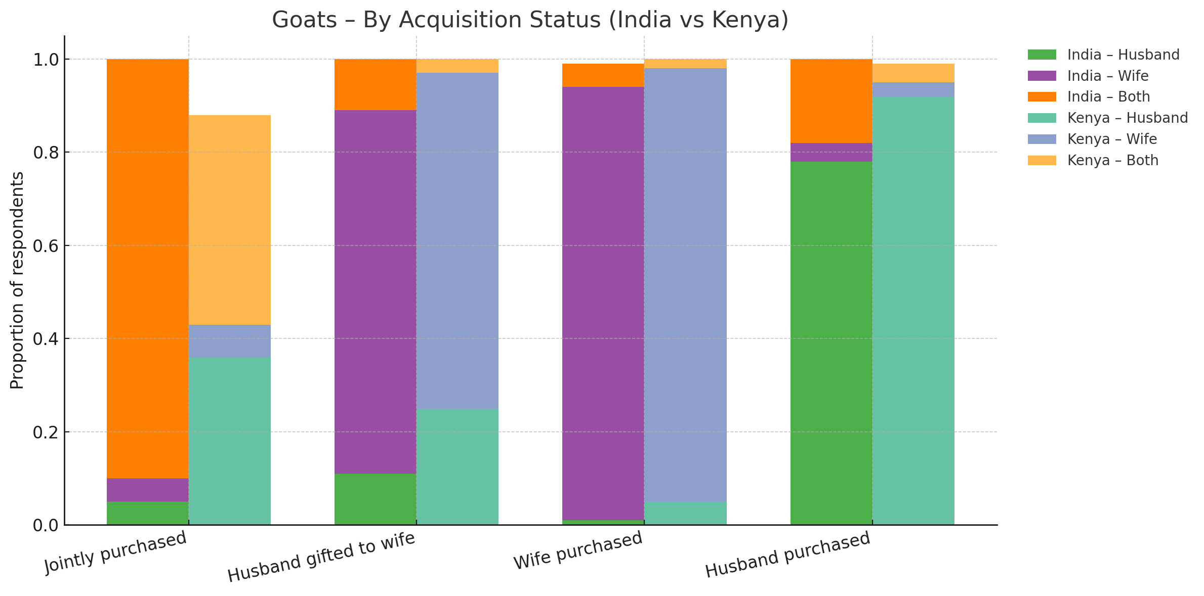

How the asset was acquired matters because in the scenario where one person purchased or inherited the asset, there is a majority consensus on who should receive the asset, especially in Kenya. For all types of assets in Kenya more than 90% of respondents say that the spouse who purchased or inherited the asset is entitled to it upon divorce (except for wife purchasing land at 87%). One exception to this is in India when either the husband purchased or inherited the asset. Although the majority of respondents still answered that the husband should receive the asset, a sizeable portion of respondents say that the asset should be given to both (about 15% to 30%) depending on the asset.
More than 70% of respondents in both countries agree that being gifted livestock entitles the wife to keep the asset upon divorce. In Kenya, however, the remaining respondents are more likely to answer the husband compared to India. In India, half of the remaining answers chose that the husband should receive the livestock, while the other half chose both.
In contrast to India, the scenario where both spouses purchased the asset in Kenya is the scenario where there is less agreement on who should have the asset upon divorce. The type of asset also affects respondents’ answers. In India, when both the husband and wife purchased the asset, the majority responded that both individuals should receive the assets upon divorce.
In India, the question of the land being owned jointly, being purchased by the husband while the wife does housework, elicits a different response compared to when told the husband purchased the land only. About 70% answered both should have it when additional information about house and care work is added. While only 30% answered “both” when the husband purchased is the only thing that is mentioned. This is true for both land and housing.
Information on the ownership of livestock matters because when the respondents were told that the goat belonged jointly to the couple, 56% said that the goats should be divided equally and 38% answered that each member of the couple should take back their own contribution. When they were told that the husband has two goats and the wife has one, 43% now answered that the goats should be divided equally.
For each country, we conducted a regression analysis to determine whether specific covariates correlate with respondents’ answers. We modify the dependent variables of interest depending on what is the most answered in a country, what options are available, and what makes it easier to compare across the different scenarios within a country. In Cote d'Ivoire, the dependent variable of interest is whether a person answered that the assets should be shared equally. We found that, for the scenario of 2 goats belonging to the husband and 1 to the wife, women are more likely to answer that the goats should be divided equally. Nothing else was statistically significant at the 10% level. For Kenya and India, different variables were statistically significant in the regression results depending on the asset and scenario.

    - Tool 2 Summary and Recommendations
Tool 2 suggests that the simple phrasing of “owned jointly” may not be enough to solicit information on whether an asset is distributed to the owner upon divorce. Practitioners should thus be cautious of using this measure alone as a proxy for outside options or bargaining power in the household. In the multiple contexts where the tool was tested, how the asset was acquired, the type of asset, and the quantity of asset being divided will matter for people’s perception on how the assets will be allocated.
Understanding the contribution of each spouse (whose money was used to buy the asset) is important even though certain contributions are valued as less than others. The case of India showed that despite the sentence stating both “owned” the land and was purchased after marriage, the scenario where “both purchased the land with combined income” vs “husband purchased while husband does care work” received different responses. This suggests that the contribution of care work by women is viewed as less valuable than income. However, some contribution still matters given that the response to the latter is widely different from the scenario response for “husband only purchased the land”.

  - Tool 3 Understanding the Meaning of Ownership

    - Tool Motivation and Design
Tool 3 asks respondents what ownership and rights tend to look like in the community. Would a person’s right and control depend on the household structure and living arrangements: (1) couple living with in-laws, (2) couple household without in-laws, and (3) being a daughter living with parents. Respondent is told about a hypothetical woman who has used her money to purchase a (female) goat. The woman has a certain living arrangement. After being read three to four statements, the respondents were asked to identify which statement describes most households in the community. Individuals are allowed to choose more than one statement. The tool was tested in Kenya and Cote d’Ivoire.
Figure 6. Tool 3
Example with Goat and Couple with in-laws
READ: Now I am going to read you some scenarios about different individuals and the types of decisions that they can make. This question format is different from the rest so take your time in answering. For each I will then ask you if the scenario resembles households in your community and which one is most like households in your community. There are no right or wrong answers to these questions.
A woman saves her money to purchase a (female) goat. She lives with her husband and his parents.
ENUMERATOR NOTE: Read aloud each story, subsequent questions, and response codes.
1. | The woman owns the goat and any offspring from the goat. She can decide what to do with the milk and whether to sell or give away the kids. | Does this scenario resemble households in your community?  Response codes  1 = Yes  2 = No
2. | Now let’s say, the woman owns the goat and can decide what to do with the milk. But her husband must agree if she wishes to sell or give away the goat or the kids.
3. | Now let’s say, the woman owns the goat and can decide what to do with the milk. But her in-laws must agree if she wishes to sell or give away the goat or the kids.
4. | Now let’s say the goat belongs to the household. As the household head, her father-in-law makes decisions about whether to sell the goat or the kids.
5. | Of the four scenarios, which resembles households in your community most? | Response codes  1 = (Woman decides to sell goats)  2 = (Husband must agree to sell)  3 = (In-laws must agree to sell)  4 = (Household head decides to sell goats)

Several versions of the tool were tested: (1) types of assets being asked and who purchased the asset, (2) choose the most common in community vs all scenarios in community, and (3) addition of question “which household the respondent is most similar to”.
Depending on the country, different asset classes were included. Questions about goats were asked for both countries. In Cote d’Ivoire, however, additional questions on assets used for transportation such as a bike and bicycle were also asked. The questions on transportation included variation in the way that the asset was purchased.
Lastly, the question of “which household is the respondent most similar to” was added in Kenya. Given that the respondents in Kenya were allowed to choose multiple scenarios, this question could be used to infer which scenario would be the most common one in the community. However, one should be careful when using this question for this purpose since it is not the same as the original question of which scenario captures the norms of most households in the area.

4.3.2. Key Findings
Figure 4.3.1 documents the share of respondents’ answers for Cote d’Ivoire and Kenya for the question of which is the most common in your community. In Kenya, respondents were allowed to choose multiple scenarios which led to an above 100% total if one aggregates the percentages. For Cote d’Ivoire, however, respondents were only allowed to choose one scenario.
Figure 7. Decision-Making Scenarios, by Household Type

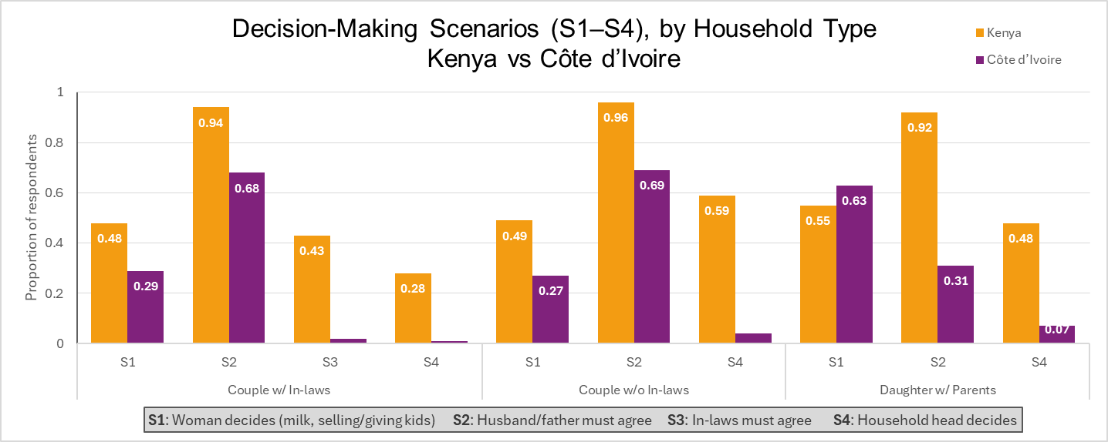

Husband must agree to sell is a common answer in both Kenya and Cote d’Ivoire. When a couple lives with or without in-laws, her husband must agree if the wife wishes to sell or give away the goat or the kids of the goat. In Kenya, more than 94% of respondents said this scenario exists in their community. In Cote d’Ivoire, close to 70% of respondents say that this scenario is the most common in the community. Daughters are more likely to have the ability to sell without needing permission rather than wives. In Kenya, 55% of respondents say that S1 exists in the community for daughters compared to the approximately 50% for wives. In Cote d’Ivoire, 63% of respondents answered that scenario S1 is the most common. In Cote d’Ivoire, respondents rarely choose S3 and S4 as the most common in the community. We cannot distinguish, however, whether this is due to the cultural context in Cote d’Ivoire or the fact the question asked for the most common instead of for all scenarios that exist (as was done in Kenya).
In Kenya, there is a variation of household type within a community. The goat being owned by the household (when couples live by themselves) was identified in the community by 59% of respondents, while 43% of respondents report that this scenario exists when daughters bought the goat. This type of variation isn’t seen in Cote d’Ivoire because only one scenario is chosen instead of multiple. In Kenya, respondents who were married were additionally asked which type of household they most resemble. Respondents still identify with S2 the most (owner with permission) when asked the question of which scenario the household resembles the most.
We conduct regression analysis to understand what correlates with individuals choosing to answer S2 (husband’s permission is required to exercise right). In Cote d’Ivoire, we did not find anything significantly correlated with choosing S2. One exception is the negative coefficient on age for the scenario of couples living with in-laws and without in-laws
In Kenya, we ran a regression for questions on whether S2 exist in the community and whether S2 is the scenario resembles your household the most. We found that statistically significant coefficients are scenario and gender dependent. Women are less likely to answer S2 for the couple household scenario in both whether S2 exist in the community and resembles the household the most.

    - Tool 3 Summary and Recommendations
Respondents’ answers from Tool 3 suggest that control over an asset in a household may not be fully decided by the owner, despite the owner purchasing the asset with her income. Permission of a spouse before selling the asset is needed for a majority of households. In Cote d'Ivoire, the sample did assign ownership status depending on whether the asset was purchased by the wife or whether the income was pooled with the husband. The husband would be able to use the assets if he needs to in either case. This result implies that collecting data on permissions in addition to ownership may be needed to understand control depending on the research question, asset type, and the type of rights practitioners are interested in. Whether the owner is a wife or a daughter living with parents also matters in determining whether permission of others is needed.
Tool 3 can be used to understand the variation of what respondents believe are the type of ownership structures that exist in the community and which one they resemble the most. Even within the same community, most Kenyan respondents answered that at least 2 household types exist.

  - Tool 4 Rights when Land is Owned Jointly
4.4.1 Tool 4 Motivation and Design
Tool 4 solicits information for how respondents view how the right to sell is exercised in the community and within their own household. Respondents were told about a hypothetical couple in three different scenarios. This tool was tested in Kenya and Malawi.
Figure 8. Tool 4
READ: I am going to read you a series of statements about a married couple and the decisions they make about agricultural land. There is no right or wrong answer. We are interested in your opinion.
Scenario 1: Peter and Grace are married. Peter is the husband, and Grace is the wife. They own a plot of agricultural land together, that they purchased after they were married.
Statement A: Neither can sell the land without the other’s agreement.
Statement B: Peter can sell the land on his own, regardless of what Grace wants. Grace cannot sell the land.
Statement C: Grace can sell the land on her own, regardless of what Peter wants. Peter cannot sell the land.
Statement D: Either can sell the land without the other’s agreement.
1. | Which situation is most common in your community? | Response codes  1 = Statement A  2 = Statement B  3 = Statement C  4 = Statement D
2. | Which couple is most like you? (FOR MARRIED RESPONDENTS)
Scenario 2: Peter and Grace are married. Peter is the husband, and Grace is the wife. Grace has a plot of agricultural land that she inherited.
Statement A: Neither can sell the land without the other’s agreement.
Statement B: Peter can sell the land on his own, regardless of what Grace wants. Grace cannot sell the land.
Statement C: Grace can sell the land on her own, regardless of what Peter wants. Peter cannot sell the land.
Statement D: Either can sell the land without the other’s agreement.
3. | Which situation is most common in your community? | Response codes  1 = Statement A  2 = Statement B  3 = Statement C  4 = Statement D
4. | Which couple is most like you? (FOR MARRIED RESPONDENTS)
Scenario 3: Peter and Grace are married. Peter is the husband, and Grace is the wife. Peter has a plot of agricultural land that he inherited.
Statement A: Neither can sell the land without the other’s agreement.
Statement B: Peter can sell the land on his own, regardless of what Grace wants. Grace cannot sell the land.
Statement C: Grace can sell the land on her own, regardless of what Peter wants. Peter cannot sell the land.
Statement D: Either can sell the land without the other’s agreement.
5. | Which situation is most common in your community? | Response codes  1 = Statement A  2 = Statement B  3 = Statement C  4 = Statement D
6. | Which couple is most like you? (FOR MARRIED RESPONDENTS)

4.4.2. Key Findings
Figure 9 documents the share of respondents’ answers for Malawi and Kenya for the question of which is the most common in your community.
Figure 9 Understanding Joint Ownership: Most Common in the Community
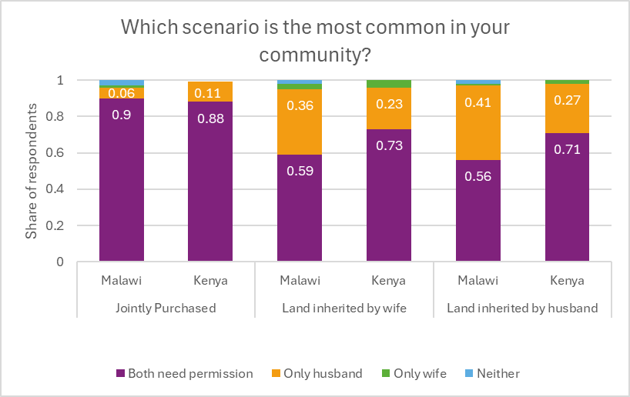

Agreement is a necessary or a common feature of joint ownership. The most common answer was decision making structure presented in Statement W, “neither can sell the land without the other’s agreement”, which was chosen by the majority in all scenarios. For the scenario where no inheritance information was given (the land was purchased by both) 88% in Kenya and 90% in Malawi answered that agreement of both spouses is needed.
Information on who inherited the land will change the respondent’s answer. When the inheritance scenarios were given, about 20 to 40% of respondents answered that the person who inherited the land has the right to sell is the most common type of household in the community. This compares to only 6% (Kenya) and 11% (Malawi) who answered that only the husband has the sell right when no inheritance information is given. The acquisition of land is thus important in soliciting information concerning the right to sell.
Countries vary in the share of individuals answering that both spouses need permission is the most common household when inherited information is given. In Kenya, for land inherited by men or women, about 70% of respondents still answered that both spouses’ permission is needed to sell. This contrasts with approximately 56-59% in Malawi, a much lower percentage.
When looking at responses to the question on which scenario resembles the household the most, most individuals identify with statement W: both need permission to sell. Overall, there is consistency between answers of most common household in community vs household that most resembled the individual, especially for the scenario when inheritance information is given. Table 2.5.1 provides the share of individuals who say that they most identify with x conditional on individuals who say that the most common household decision making structure is x. For example, in Kenya, out of the 21.3% of individuals who responded that the wife could sell the land is the most common type of household in the community, 69.3% also identify as this type of household. The majority of the households (more than 50%) do say that they resemble “x” conditional on them saying that “x” is the most common in the community. One outlier is the 12.3% in Kenya who answered that husband can sell their land is the most common in the community. Only 29.1% of these households claim they resemble this type of household.
We conduct three types of regression analysis. The first one looks at the question of: do the inheritance scenarios receive different responses compared to the purchased scenarios? This regression was only done in Kenya given that randomization was done where in one treatment arm inheritance information was not given while in another arm it was given. We can thus test whether providing this information changes the response and whether it is statistically significant.
Our findings show that providing inheritance information affects the probability of a respondent answering that permission from both spouses is needed before selling the land. When inheritance information is not provided, treatment arm 1, respondents are more likely to answer that permission of both spouses is needed. We also see that the coefficient on females is significant only when interacted with treatment arm 1 (when no inheritance information is given). Men and women’s answers are thus more consistent when inheritance information as given.
Our second regression looks at: what variables correlate with household answering that the permissions of both spouses are needed before selling the land? Are certain types of respondents more likely to answer this option? We conduct additional regression analysis looking at what type of variables correlates with the most common answer: Neither spouses can sell the land without the other’s agreement.
For both Kenya and Malawi, different covariates are statistically significant depending on whether it is the asked for the community or the household and which scenario is being asked. In Kenya, the coefficient on female was negative correlated with answering W and statistically significant only for the basic scenario (both spouses purchase the land). In Malawi, this was also the case when statement ordering, and scenario ordering was not included in the regression. After the inclusion of the two, the coefficient becomes not significant.

In Kenya, for most common in community, more educated respondents were less likely to answer W when asked the question with inheritance scenario. This is also the case for those whose religion is traditional. For the household type closest to, respondents are more likely to answer W if the respondent assisted in the family business (only in the inheritance scenarios). When respondents were asked about the household type closest to under when female inherits land, married individuals are more likely than single to answer W. When a person has use rights or owns land, they are also less likely to answer W (although this coefficient is less negative if the person has the right to sell or own a land that was purchased).

In Malawi, when the respondent owns a dwelling, the respondent is less likely to answer W. There are other coefficients that are statistically significant, however, they do vary by scenario and community/household. These covariates are age, education, religion, marriage, household size, employed in own business.

The order of which scenario is read, on the other hand, does matter. When inheritance scenarios are asked first, respondents are less likely to answer statement W (both spouses' permissions are needed) when asked the most common in community for the scenario of land purchased by both. For land inherited by men and by women, however, respondents were more likely to answer W. When the respondent was asked about their own household, respondents were more likely to answer W for when women inherits if women inherit scenario was asked first. Similarly, they are more likely to answer W for when men inherit land if this scenario was asked first. These two results suggest that some type of priming might be happening and require further investigation.

4.4.3. Tool 4 Summary and Recommendations
Results from Tool 4 suggest that one may not need the permission of the spouse to exercise the right to sell depending on how the land was acquired. For the two pilot countries, permission of both spouses is a must when land is purchased together using the income of both spouses. When inheritance scenarios were read, respondents answers split into two: both permissions are still needed versus the person inheriting the land can make a sole decision, although the majority still chose the former. Like the previous tool, this result adds to the motivation for eliciting permission information of the spouse or other members of the household who are not necessarily owners since these household dynamics are important.
Our results also highlight areas where practitioners should be careful of the potential ordering of statements due to possible priming. Randomizing which scenarios people receive might be helpful. Very few respondents in any scenario choose the last statement of “either can sell the land without the other's agreement”.

  - Tool 6 Control and Benefits Over Assets Scale

    - Tool 6 Motivation and Design
Tool 6 aims to simplify the process of collecting information on asset ownership. Respondents are asked about the core dimensions of control over and benefits over assets. There are 16 sub questions covering 6 or five asset classes depending on the country: land, dwelling, livestock, mobile phone, large appliances, and mode of transportation. This tool was tested in Uganda and India, and the tool randomized the levels of answers that are possible, 5-level vs 3-level Likert scales. The order of the items was also randomized.
Figure 10. Tool 6
ENUMERATOR READ: You answered that someone in your household owns, controls, or benefits from [asset]. We will now ask you some questions regarding your access to this asset.
A. | I have [asset] that I can use | Response codes  1 = Completely Disagree  2 = Mostly disagree  3 = Neither agree nor disagree  4 = Mostly agree  5 = Completely agree
B. | I have [asset] that I can use whenever I want
C. | I have [asset] that I can use however I want
D. | I have [asset] that I can use to produce things for household consumption (not for transport or phones)
E. | I have [asset] that I can use to produce things for sale (not for transport or phones)
F. | I decide how the economic benefits from [asset] are distributed among household members
G. | I have [asset] for which I can make improvements
H. | Because I have [asset], I feel more protected in the face of a shock
I, | I have [asset] I can pass on to my children
J. | I have [asset] I can use to earn income (e.g. to rent out)
K. | Because I have [asset], people in my community respect me
L. | I have [asset] I can use as collateral or gives me access to credit
M. | What happens to [asset] mostly depends on me
N. | Other people determine most of what I can and cannot do with [asset]
O. | There are many things that interfere with my use of [asset]
P. | I would keep [asset] if I separated from my spouse or partner

4.5.2. Key Findings
General statements on the use of an asset show high levels of agreement with a statistically significant gender gap. Other statements of control or benefits, however, could have much less agreement and a higher gender gap. In Uganda and India, more than 87% of respondents answered that they have an asset that they can use with a gender gap of about 7.2% and 3.5% respectively (higher share for men). The statement on having the ability to decide on the economic benefits of the assets had 37% of women agreeing while 70% of men agreeing in Uganda (84% for women and 52% for men in India). Other statements that show a large gender gap for land include ability to make improvements, asset mostly depends on me (highest gender gap), keeping asset if separated from spouse (only significant in Uganda), ability to pass on asset to children (only significant in Uganda), and able to use asset for collateral. The differences in answers across countries and variation in gender gaps do tell us that the responses to these statements are heavily context specific, even for the same type of asset.
Figure 11. Control/Benefits over Land in India and Uganda
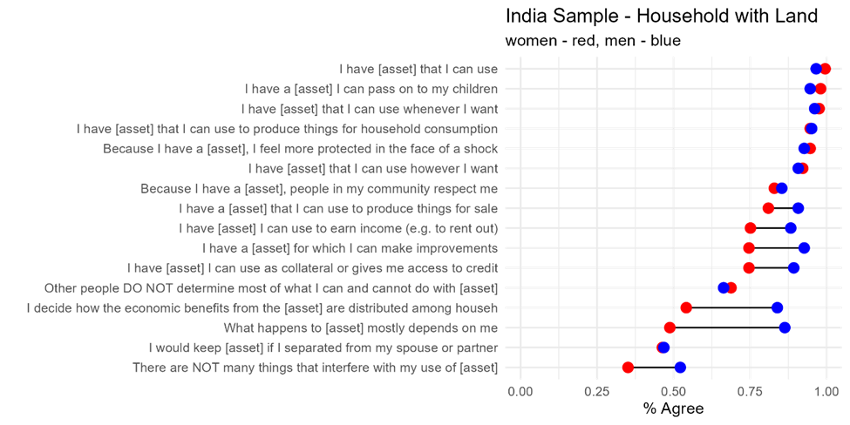
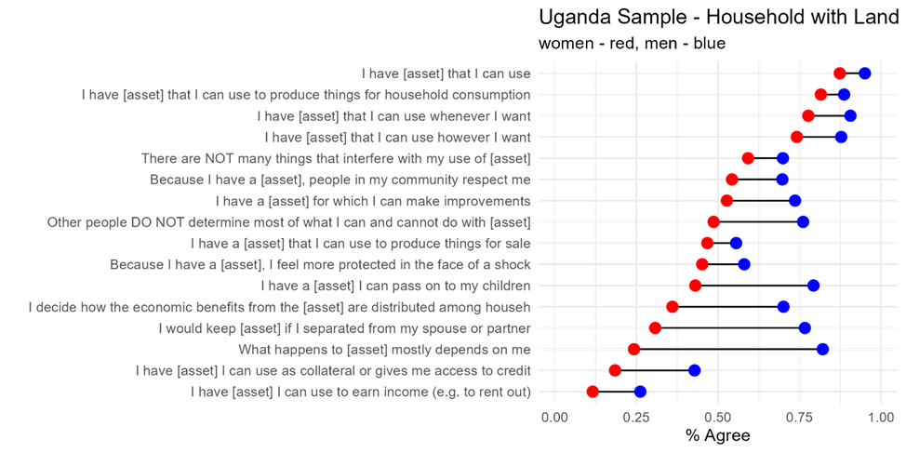
Given that Tool 6 is a scale instead of a vignette, we also confirm structural validity and internal reliability of the scales. Cronbach’s Alpha is greater than .6 across 98% of assets and samples therefore confirming the internal reliability of the scale.

    - Tool 6 Summary and Recommendations
Measuring the type of control and benefit that individuals receive from an asset is quite difficult given that there are various forms of control and benefits one could receive. MAGNET approached the issue by designing 16 sub-questions for this purpose and a naïve measure of the questions revealed that it was able to capture variation in control over assets and to find gender gaps that varies by statement. This tool can be used to create an index that measures overall control and benefit as well as understand how the index varies by gender and other individual characteristics.

5. Conclusion
Despite notable progress in recent years, there are still many open questions in literature concerning our understanding of what ownership and control entails, how these concepts vary across contexts, and how best to measure them. More progress also needs to be made on how to solicit information about ownership in terms of word choice, survey contexts, as well as interview methodologies that reduce bias during the interview. These questions are important to answer given the policy goals of improving ownership of assets for those who are vulnerable and the interest to measure ownership in various country contexts.
This paper contributes to filling these gaps by presenting evidence from five newly developed MAGNET tools designed to better understand these concepts. Each of the tools aims to increase our understanding of ownership and how to properly measure aspects of control over assets. Multiple versions of the tools are tested, and results are discussed to ensure the validity of the tools.
Tool 1 Preferences over Joint vs. Individual Asset Rights illustrates that researchers should not always assume joint ownership is preferred to owning exclusively part of an asset. There is variation by country context on the share of individuals who believe that wife would prefer joint ownership. This variation depends also on the type of assets and how the asset would be divided.

Tool 2 Asset Rights upon Marriage Dissolution suggests that the simple phrasing of “owned jointly” may not be enough to solicit information on whether an asset is distributed to the owner upon divorce. How the asset was acquired, the type of asset, and the quantity of assets being divided matter for people’s perception on how the assets will be allocated.

Tool 3 Understanding the Meaning of Ownership suggests that control over an asset in a household may not be fully decided by the owner, despite the owner purchasing the asset with her income. Permission of a spouse before selling the asset is needed for most households. Whether the owner is a wife or a daughter living with parents also matters in determining whether permission of others is needed.

Tool 4 Rights when Land if Owned Jointly suggests that one may not need the permission of the spouse to exercise the right to sell depending on how the land was acquired. The result of the previous two tools adds to the motivation for soliciting permission information of the spouse or other members of the household who are not necessarily owners since these household dynamics are important.

Tool 5 Control and Benefits over assets allow us to capture dimensions of control and benefit. This tool can be used to create an index that measures variation in control and benefits as well as understand gender gaps of the different dimensions.

We hope the findings and recommendations presented will motivate practitioners to consider the inclusion of these validated tools in household surveys seeking to measure asset ownership and control. Results from the MAGNET tools further bolster findings from the Gender Asset Gap Project, MEXA, LSMS+, and others that highlighted the need for asset information to be collected at the individual level and to collect information on a bundle of ownership constructs and rights. The MAGNET tools show that to truly capture the nuances of preferences regarding ownership and how different sub-populations view their own ownership and rights, that surveys must go even further in the information they collect. Recognizing the many demands on and limited space in large-scale multi-topic household surveys, the vignettes may be better suited for small-scale surveys or pilot studies while the scale was designed for inclusion as part of larger scale surveys. Training protocols for each tool can be found on the MAGNET Resource Center can provide some guidelines for practitioners investigating related questions and the measurement of ownership.

References
Ali, Daniel Ayalew, Klaus Deininger, and Markus Goldstein. "Environmental and gender impacts of land tenure regularization in Africa: Pilot evidence from Rwanda." Journal of Development Economics 110 (2014): 262-275.
Allendorf, Keera. "Do women’s land rights promote empowerment and child health in Nepal?." World development 35.11 (2007): 1975-1988.
Amankwah, Akuffo; Johnson, Darcey Jeanne Genou; Ofori Adofo, Josephine; Gul, Maryam; Palacios-Lopez, Amparo. Measuring Poverty in Tanzania: Comparison of Diary and Recall Approaches to Food Consumption Data Collection (English). Policy Research Working Paper; Washington, D.C.: World Bank Group. http://documents.worldbank.org/curated/en/099815008192411379/IDU1cb9ca78a12eb6143bb1b2f31c8aed23cfc54
Amaral, Sofia. "Do improved property rights decrease violence against women in India?." Available at SSRN 2504579 (2017).
Bernard, T., Doss, C., Hidrobo, M., Hoel, J., & Kieran, C. (2020). Ask me why: Patterns of intrahousehold decision-making. World Development, 125, 104671.
Calvi, Rossella. "Why are older women missing in India? The age profile of bargaining power and poverty." Journal of Political Economy 128.7 (2020): 2453-2501.
Deininger, Klaus, et al. "Inheritance law reform, empowerment, and human capital accumulation: Second-generation effects from India." The Journal of Development Studies 55.12 (2019): 2549-2571.
Dillon, Brian, and Alessandra Voena. "Widows' land rights and agricultural investment." Journal of Development Economics 135 (2018): 449-460.
Diana Deere, C., Alvarado, G. E., & Twyman, J. (2012). Gender inequality in asset ownership in Latin America: Female owners vs household heads. Development and change, 43(2), 505-530.
Donald, A., Koolwal, G., Annan, J., Falb, K., & Goldstein, M. (2020). Measuring women’s agency. Feminist Economics, 26(3), 200-226.
Doss, C., Kovarik, C., Peterman, A., Quisumbing, A., & Van Den Bold, M. (2015). Gender inequalities in ownership and control of land in Africa: myth and reality. Agricultural Economics, 46(3), 403-434.
Doss, C., Kieran, C., & Kilic, T. (2019). Measuring Ownership, Control, and Use of Assets. Feminist Economics, 26(3), 144–168. https://doi.org/10.1080/13545701.2019.1681591
Cheryl Doss, Carmen Diana Deere, Abena D. Oduro, Hema Swaminathan, Suchitra J. Y., Rahul Lahoti, W. Baah-Boateng, L. Boakye-Yiadom, Jackeline Contreras, Jennifer Twyman, Zachary Catanzarite, Caren Grown, and Marya Hillesland. The Gender Asset and Wealth Gaps: Evidence from Ecuador, Ghana, and Karnataka, India. Bangalore: Indian Institute of Management Bangalore. 2011.
Fafchamps, Marcel, and Agnes R. Quisumbing. "Control and ownership of assets within rural Ethiopian households." Journal of development Studies 38.6 (2002): 47-82.
Clare Clingain, Aletheia Donald, and Maria Hernandez-de-Benito “Measuring Agency Through Psychological Constructs in Lower-Income Settings”
Goldstein, Markus, et al. "Formalization without certification? Experimental evidence on property rights and investment." Journal of Development Economics 132 (2018): 57-74.
Hasanbasri, A., Kilic, T., Koolwal, G., and Moylan, H. (2021.) LSMS+ Program in Sub-Saharan Africa: Findings from Individual-Level Data Collection on Labor and Asset Ownership (English). Washington, D.C.: World Bank Group. http://documents.worldbank.org/curated/en/240461620192973394/LSMS-Program-in-Sub-Saharan-Africa-Findings-from-Individual-Level-Data-Collection-on-Labor-and-Asset-Ownership
Hasanbasri, A., Kilic, T., Koolwal, G., & Moylan, H. (2023). Multidimensionality of Landownership among Men and Women in Sub-Saharan Africa. The Journal of Law and Economics, 66(3), 581-608.
Harari, Maria Flavia. "Women’s inheritance rights and bargaining power: Evidence from Kenya." Economic Development and Cultural Change 68.1 (2019): 189-238.
Kieran, C., Sproule, K., Doss, C., Quisumbing, A., & Kim, S. M. (2015). Examining gender inequalities in land rights indicators in Asia. Agricultural Economics, 46(S1), 119-138.
Kilic, Talip; Moylan, Heather. 2016. Methodological Experiment on Measuring Asset Ownership from a Gender Perspective. World Bank, Washington, DC. http://hdl.handle.net/10986/33653 License: CC BY 3.0 IGO.
Malapit, H., Quisumbing, A., Meinzen-Dick, R., Seymour, G., Martinez, E. M., Heckert, J., ... & Team, S. (2019). Development of the project-level Women’s Empowerment in Agriculture Index (pro-WEAI). World development, 122, 675-692.
Masset, E. (2015). Measuring empowerment in rural India using vignettes. Journal of Development Effectiveness, 7(3), 346–356. https://doi.org/10.1080/19439342.2015.1068355
Meinzen-Dick, Ruth, et al. "Women's land rights as a pathway to poverty reduction: Framework and review of available evidence." Agricultural systems 172 (2019): 72-82.
Melesse, Mequanint B., Adane Dabissa, and Erwin Bulte. "Joint land certification programmes and women’s empowerment: Evidence from Ethiopia." The Journal of Development Studies 54.10 (2018): 1756-1774.
Milazzo, Annamaria, and Dominique Van de Walle. "Nutrition, religion, and widowhood in Nigeria." Economic Development and Cultural Change 69.3 (2021): 951-1001.
Mookerjee, Sulagna. "Gender-neutral inheritance laws, family structure, and women’s status in India." The World Bank Economic Review 33.2 (2019): 498-515.
Samek, A., Kapteyn, A., & Gray, A. (2022). Using vignettes to improve understanding of Social Security and annuities. Journal of Pension Economics & Finance, 21(3), 326-343.
Slavchevska, V., Doss, C. R., de la O Campos, A. P., & Brunelli, C. (2020). Beyond ownership: women’s and men’s land rights in Sub-Saharan Africa. Oxford Development Studies, 49(1), 2–22. https://doi.org/10.1080/13600818.2020.1818714
World Bank. “Measuring Women’s Control Over Assets.” World Bank, Washington, DC. 2021. http://hdl.handle.net/10986/36271 License: CC BY 3.0 IGO.

See MAGNET Policy Brief World Bank 2021 Measuring Women’s Control Over Assets.
https://magnet.ifpri.info/
MAGNET is a collaboration between the World Bank’s Africa Gender Innovation Lab (GIL) and the Living Standards Measurement Study (LSMS), the International Food Policy Research Institute (IFPRI), the International Rescue Committee (IRC), and researchers at Tufts University and University of Oxford.

