Land grabbing, deforestation, and conversion to pasture in the Northwestern Arc of the Colombian Amazon

Foundation for Conservation and Development-FCDS, 2023
61% of national deforestation in 2021 took place in the Colombian Amazon biome (912,314 ha) (IDEAM, 2022) The main focus is placed in the Northwestern Arc of the Amazon. This area was a strategic territory for the Revolutionary Armed Forces of Colombia-People's Army-FARC guerrilla (Eastern Bloc). Control over this area enabled the connection among Meta, Guaviare, and Caquetá by connecting the municipalities of La Macarena, San Vicente del Caguán, and Cartagena del Chairá, and the center (Sumapáz) with the Southwestern part of the country (Neiva and Florencia)(FIP, 2015) . The roads opened by the FARC, extending for hundreds of kilometers through the jungle, not only played a strategic role in the war but also paved the way for the colonization of the Arc. For the guerrilla, forests were a strategic asset serving as shelters and corridors without being detected. Ecological regulations known as gunpoint conservation allowed FARC controlling the territory by controlling the population and the nature (Aguilera, 2013; Gentry & Spencer, 2010; Pecaut, 2008). As a result, logging, hunting, fishing, and any alteration of the ecosystem was regulated by the community and punished by the guerrillas (Gómez, 2018; Urdaneta, 2017). Upon signing the peace agreement between the Colombian government and the FARC in 2016, control over the territory was deregulated. The regulation vacuum left by the FARC opened the door to illegal armed structures related with organized crime and FARC guerrilla dissidents with experience in the territory. In this area, land grabbing consolidation relies on the expansion of illegal sub municipal road network on illegally appropriated public lands (baldíos) that gain value with deforestation and the investment of public resources. Specifically, as stated by the Minister for the Environment, “the conversion to pasture aimed at land grabbing, unsustainable, extensive livestock farming, crops for illicit use, the development of unplanned transportation infrastructure, the illegal extraction of minerals, illegal logging, and the expansion of the agricultural frontier in areas that are not allowed, are the main causes of deforestation in the country” (Ideam 2022 in Muhamad 2022).
Conceptualization of land grabbing in the Colombian Amazon
In the absence of cadastral information in the study area, it was not possible to analyze the actual size of properties, ownership and land property accumulation as a result of land grabbing. Therefore, deforestation was taken as a spatial indicator that allows georeferencing patterns of land use change associated to slash and burn and the conversion to pastures as a mechanism of land grabbing using cattle. In order to deforest, land must be occupied, appropriated or used. In the case of the Colombian Amazon, land grabbing is possible by the appropriation of public lands (baldíos), collective territories of ethnic communities or environmental protected territories. Lands of the forest reserve zones and natural parks are unallocated reserved lands, and as with reservations (only titled to ethnic communities) and therefore, they are not in the legal land market. However, restrictions on individual property rights in the Amazon do not limit the land market, but they are a price variable in the dynamic informal market tied to deforestation.
For that reason, the value of deforested land under these categories change in every area and depends on its productivity and changes significantly depending on the distance from the roads connections to infrastructure, and the conversion to pastures as requisite for cattle breeding, as it will be shown in every zone. It´s not a coincidence that deforestation has occurred in the same hotspots where livestock has increased by 96.4% between 2016 and 2022 -from 1.143.346 to 2.245.534- (ICA 2022).
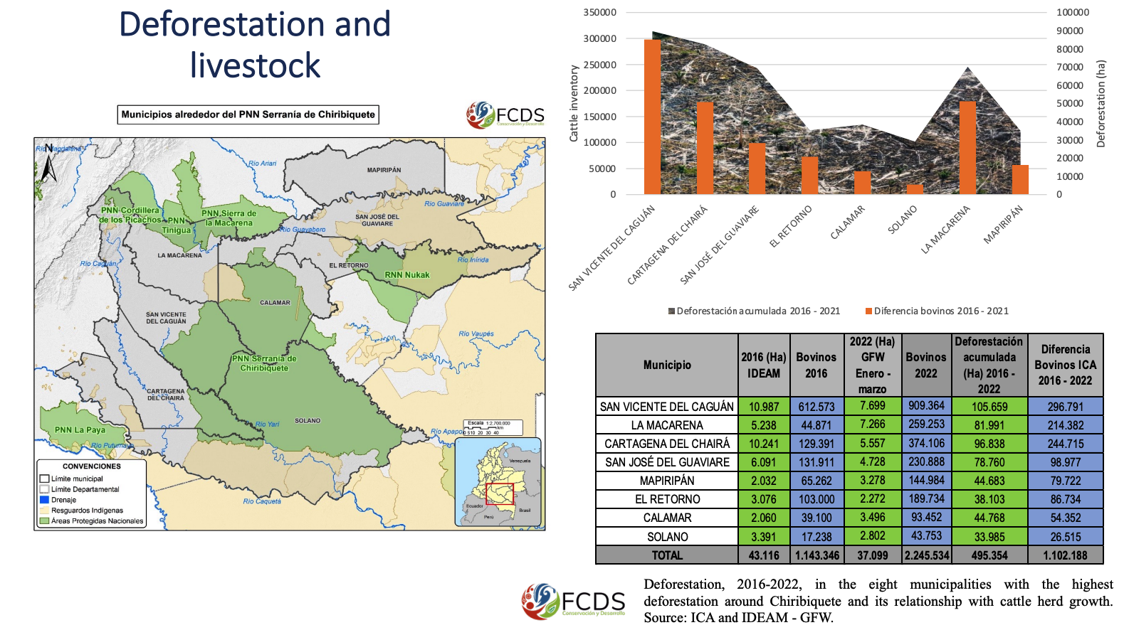
Deforestation, 2016-2022, in the eight municipalities with the highest deforestation around Chiribiquete and its relationship with livestock increasing. Source: ICA and IDEAM – GFW processed by FCDS
After the Amazon forest reservation, deforestation connected to the conversion to pastures and land grabbing threatens the integrity of natural parks. From April 2021 to March 2022, 8,216 ha have been deforested in Tinigua PNN, 4,062 ha in Sierra de la Macarena PNN, 1,862 ha in Serranía de Chiribiquete PNN, 713 ha in La Paya PNN, 286 ha in Cordillera de los Picachos PNN, and 236 ha in RNN Nukak (IDEAM, 2022, FCDS 2022), which shows the fragility of strategic ecosystems in the short term due to deforestation. For that reason, livestock is an indicator of land grabbing in natural parks and indigenous territories.

Just between March 2021 and April 2022 Indigenous reservation Nukak - Makú lost 1.534 ha and Llanos del Yarí Yaguará lost 5.472 ha by the deforestation. At the same time, there are 8,218 vaccinated cows in the Caño Makú trail inside the Nukak reservation and 7,420 in the Gualandayes trail (ICA, 2021); these two trails are active deforestation hotspots and two of the areas with the highest cattle vaccination in 2021 in Guaviare (ICA, 2021).
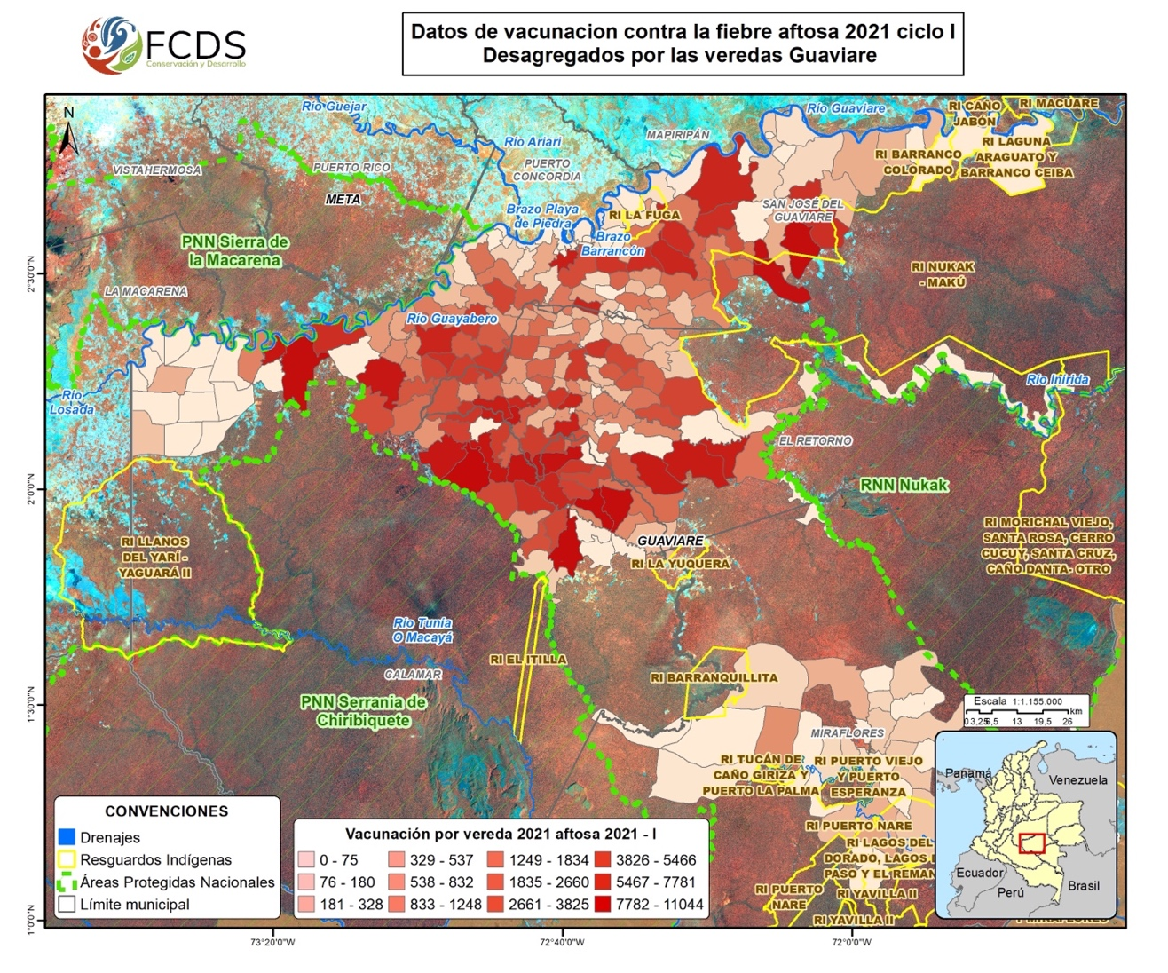
Livestock vaccination in Guaviare 2021 (ICA, 2021)
Speculation associated with land grabbing takes place in those areas. Illegally appropriated public lands once deforested and transformed into pastures are traded in the market where the individual profit of the speculation is consolidated allowing land grabbing. According to local settlers of this area, there is a new dynamic called "augmentation" to understanding the business in the region. This figure lends itself to hide the name of the real investors who delivsker cattle to farmers, who, although they are obliged to register as holders with the health authorities, do so as owners.
"When there are cattle on the increase, the first thing (I must do) is to go to the ICA and register as a holder. (In this scheme) the holder is the one who has (manages) the animals. There are people who give cattle to the neighbor in increase, at the time of vaccination they must make a possession permit because otherwise the cattle will appear as theirs".
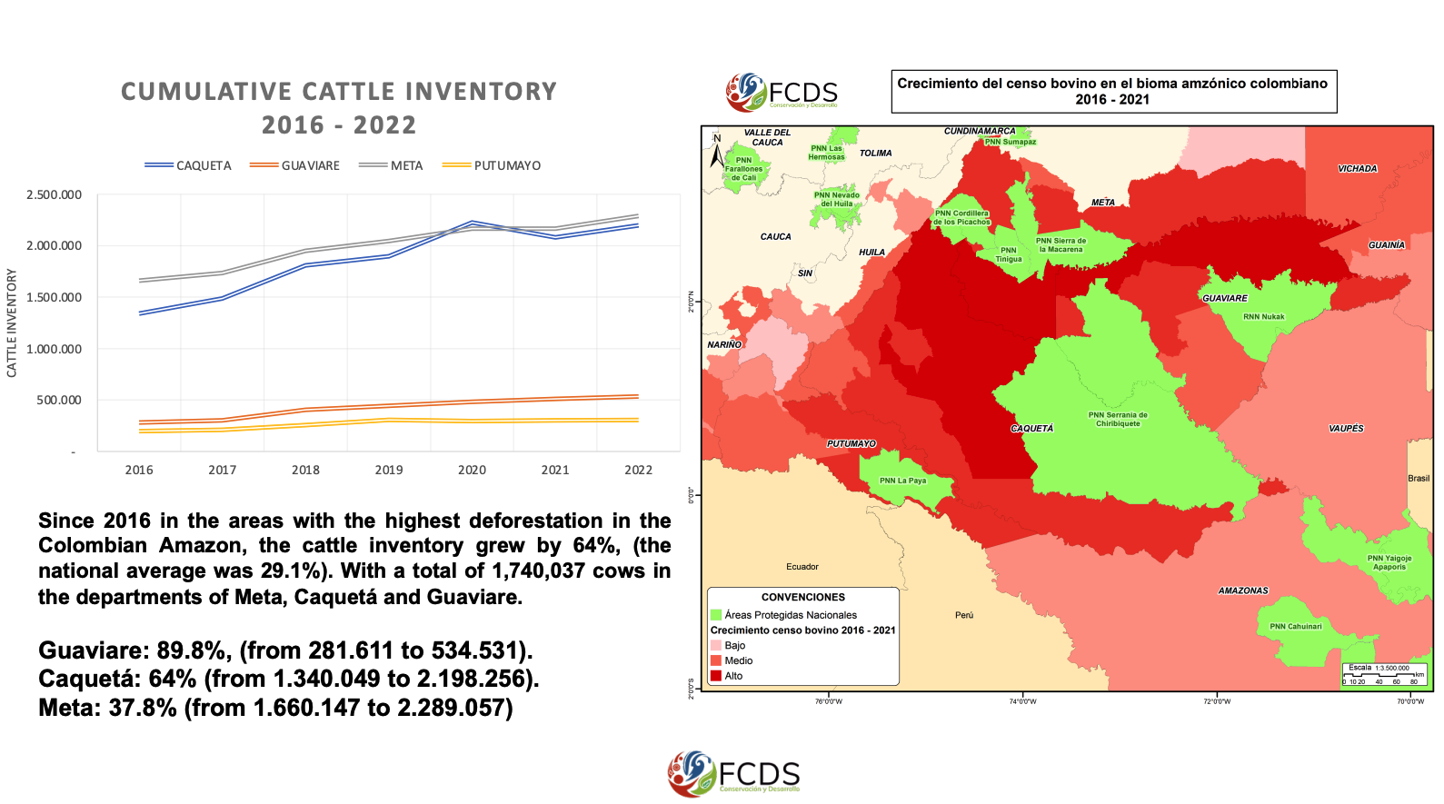
Cattle growth, 2016-2022, around the most important natural parks in Meta, Guaviare and Caquetá.
Land grabbing involves state and non-state, legal and illegal, formal and informal actors in every context. (Borras et al., 2013). It is financed and orchestrated by hidden or dubious business owners (UNODC 2022) collaborating with suppliers, intermediary landowners and the State facilitating facilitate clearing and occupying protected territories and their trade (Hernández, F. et al. 2021; Insight Crime & Igarape, 2022). Land grabbing is associated with speculation in areas with economic interests based on formal and informal transactions. Thus, land speculation is a key component to understanding deforestation allowing to foresee the areas that will be appropriated, grabbed, and transform into pastures, supporting the financial profitability of livestock, cocaine, and mining production, and the movement of significant capital flows.
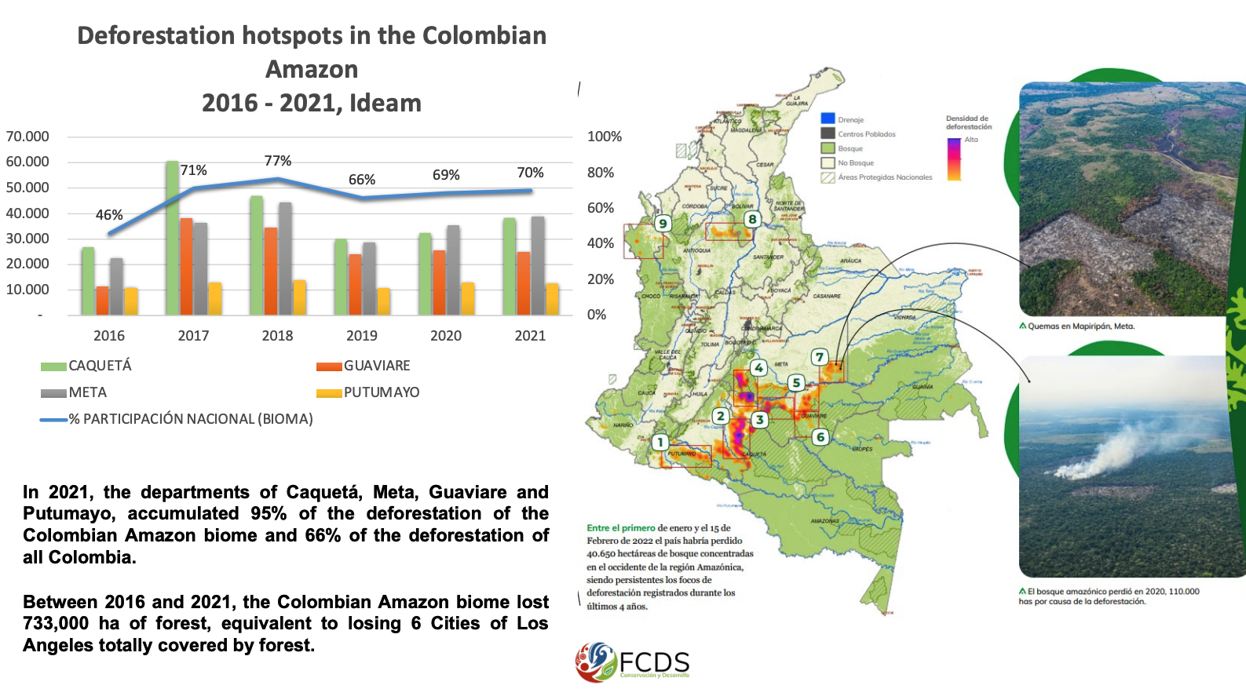
Deforestation in the Colombian Amazon biome, compared to deforestation at the national level. Source: FCDS, based on IDEAM data.

How land grabbing works in Guaviare
FCDS elaboration 2022
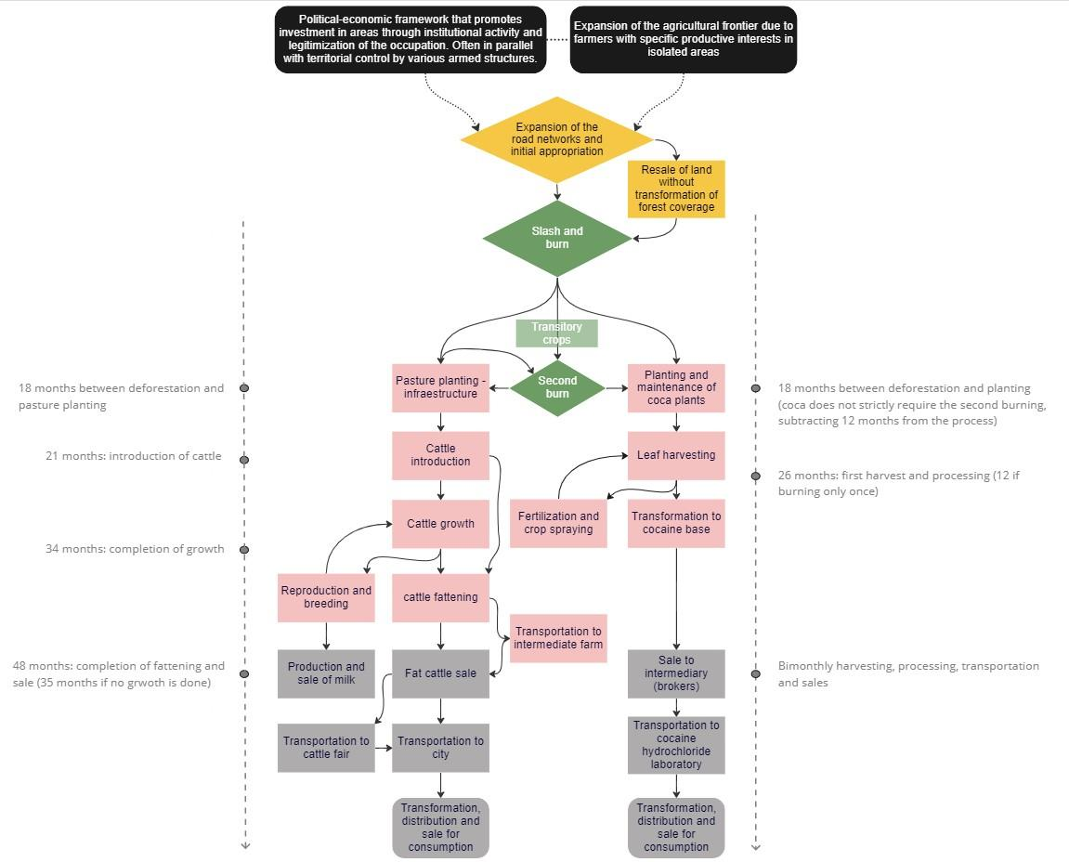
How it starts:
- The "founders" occupy 200 to 3,000 hectares of forest, delimit the properties, and create a Community Action Board where the occupation of each new farm is certified..
Materializing the speculation:
- The acquired land is converted into plots. One part is sold as jungle and others are slashed, burned, and resold as pastures (increasing the value up to 10 times). One hectare of pastures (with a deed) in areas taken out from forest reserve costs approximately USD$3,160 near San José del Guaviare, Inside the Chiribiquete Park the same hectare costs USD$320. In the forest reserve zone, where there are use contracts to regularize occupation, average prices per hectare of pasture range between USD$750 and USD$1,890.
- Price fluctuations depend on several variables such as the possibility or existence of deeds, the type and quantity of pastures, the quality and condition of the fencing, the available water sources, the distance to main roads, as well as the buyer's bargaining power.
- The legal system to protect areas is not a limiting factor for the land market but rather a price variable allowing speculation through the profit of deforested areas transform into pastures.
- Many transactions occur with informal deeds issued by the Community Action Boards in the villages.
Slash and burn
- Slash and burn one hectare of primary forest costs USD$120 (approximately in Guaviare). In some cases, corn is planted after the first burn to take advantage of the nutrients remaining from the ash, and the time prior to the second burn.
Pastures and fencing
- Planting grass has an average cost of USD$110 per hectare and is done just after burning (either the first or second).
- Grasses with high protein content (amargo - decumbens) and others with resistance to weather anomalies (llanero - humidicola) are used.
- To fence the lot, barbed wire fences and posts are used with an average price of USD$1,600 to $2,500 per kilometer (depending on the material).
Introducing and rearing cattle
- The process begins by buying cattle at average prices of USD$1.54 and USD$1.34 per kilo (depending on whether they are male or female) for breeding (0-7 months), rearing (8-22 months), and fattening (23-26).
Associated infrastructure
Building infrastructure depends on the investment capacity (corrals, milking, reservoirs, machinery, roads, housing).

Selling beef and milk cattle
- Most of the cattle fattened on these properties is collected directly from the farms by intermediaries who transport them to a cattle fair in intermediate municipalities, or directly to a producer from protected areas such as Reservations or National Parks. Cattle is commonly transported to farms with the ICA Sanitary Registry of Livestock Properties, so they may be “laundered” (EIA, 2021; UNODC, 2022).
- Currently, intermediaries have been placed in strategically located villages to gather the cattle. They have the infrastructure needed for purchase and sale transactions.
Hidden capital in the cattle business
- There are dubious and hidden investors who provide cattle to people with recently acquired land so they can complete their fattening period. This is because most farmers do not have enough starting capital to invest in young cattle, especially since they must wait up to two years sell it and receive profits (the rearing and fattening period). But they do have abundant pastures, having recently burned and fertilized the soil.
- The investor delivers the heavy cattle and the weight gain is settled between the two (sometimes 60-40) but almost always (50-50).
- Under this figure, known as the “increase,” new farms have been established in areas of intense colonization, while mainly foreign investors mobilize capital that, presumably could be associated with money laundering from illegal activities such as drug trafficking.
Coca cultivation and transformation into cocaine base
- The cost of establishing coca crops is $USD2,495/ha. FARC dissidents and organized crime provide low-interest loans to peasants and settlers so they can start growing coca. The loan is paid with a percentage of the initial sales.
- The first harvest is between seven and eight months after planting, with production cycles every two months on average.
- It is estimated that 87% of growers transform the leaf into cocaine base. (UNODC, 2022). This process requires large amounts of gasoline (around 900 liters to produce one kilo of base), as well as other inputs such as cement or lime, ammonia, and smaller amounts of sulfuric acid.
- The cocaine base is sold to a laboratory specialized in the transformation into cocaine hydrochloride (sometimes in the same area, but also in other departments, since the laboratories that perform the initial transformation are fewer in number).
- The selling price in 2022 in Guaviare is USD$748 per kilo of cocaine base, plus a surplus of USD$133 that must be paid by the buyer to the armed group controlling the area (generally FARC dissidents).
- The FARC dissidents have their own crops and laboratories in several areas of Guaviare where they control mobilization routes for transporting inputs and products to be marketed, setting “taxes” along all phases of production.

Landscape-scale deforestation is related to land grabbing and the conversion to pastures
This analysis uses the concept of Landscape to explain the spatial and quantitative correlations of land grabbing, the conversion to pastures, and deforestation that occurred in 2020 and 2021. The lack of property information does not allow to measure land grabbing as a stand-alone variable. Therefore, deforestation is one of the main expressions of land grabbing that can be mapped and measured, allowing to establish how deforested areas are generally transformed into pastures. In this regard, deforestation associated with land grabbing occurred on public lands causing land cover transformation at landscape scale depending on the dominant driver (cocaine production, livestock, road infrastructure) in each context.
Conditions associated with deforestation causes are related to quantifiable and spatially explicit variables that correspond to environmental, social, economic, and armed conflict dimensions at municipal and sub municipal levels. Consequently, 26 variables were used to assess the relationship among land grabbing, the conversion to pastures, and deforestation in 2020-2021 where exploratory data analysis, descriptive statistics, and linear and logistic regression models were integrated (Annex 2). In this sense, the linear regression allows to quantify the association between certain variables at the level of the deforested patch and at the municipal level, while the logistic models contributed to comparing the probability of deforestation given the changes in the explanatory variables at local level.
Based on the above considerations, the main findings together respond to the research questions: i) What is the quantitative role that land grabbing and praderization play in deforestation? and ii) What spatial and quantitative correlations can be established, and how do they reflect the complexity of land grabbing and praderization? To this end, the general results of the study area are shown below, and then the relationship among land grabbing deforestation and the conversion to pastures are analyzed in the five zones (clusters) in which a more local analysis was conducted.
General characteristics of the land grabbing outlook in the Northwestern Arc of the Amazon
At landscape level, the incidence of land grabbing in the Northwestern Amazon Arc is related to high deforestation densities, occurrence of fires and increasing of livestock as well as proximity to agriculture frontier, coca crops and roads, where 90% of the deforestation is less than 1 km away from areas that were deforested in the previous period. Roads are the kick-off driver allowing land-grabbing. Roads facilitate mobility of persons and infrastructure to consolidate farther deforestation patches; for that reason, there is 50% more probability that areas within 1 km from roads are deforested in the following year and 69% of the deforested area from 2020 to 2021 in the Northwestern Arc of the Amazon (61,678 hectares) is less than 2 km away from roads. Roads could be considered the golden driver allowing to consolidate other drivers and a requisite sin equa non for land grabbing. Tertiary illegal red network connects areas inside the agriculture frontier with the Amazon forest reservation zone where 41% of deforestation took place between 2020-2021.
Deforestation within forest reservations is not new. The lack of access to productive lands has historically push peasants out of the productive spaces to colonize affordable areas outside the agriculture border (Brücher, 1968; D. Fajardo, 1996; Molano, 1997; Salgado Ruiz, 2012).
This colonization pattern in the Colombian amazon has implied clearing forests to prove the plots are used following the land titling requirements for rural workers. However, land titling to consolidate communities to preserve forest has not been part of the political agenda. Settlers of the forest reservations have never been recognized by the state, impeding the historical consolidation of property rights and the cadastral system to preserve the forest. That explains why nowadays Guaviare (top deforestation department) has no rural cadastral information.
Acknowledging that deforestation is not new, what is alarming is the scale and the magnitude of the deforestation specially since FARC disarmament in 2016 (Clerici et al., 2020; Dávalos et al., 2014; Davalos et al., 2021).
Historical settlers did not have the economic muscle to consolidate economical enclaves of production in the forest because of the lack of access to public goods, services and technology to develop the production. Destitute communities have lived from the solidarity of their neighbors in what Molano call “borrow arm and hand return” as a mechanism to exchange labor to help harvesting in those isolated territories of colonization (Molano, 1997). Hence deforestation, of historical settlers was limited by their economic situation and by FARC´s ecological iron fist were deforestation was forbidden in order to preserve secure safe havens (Gómez, 2018; Moreno-Martínez, 2021).
Preservation of the forest was strategic to consolidate lines of communications among the south, the center and the eastern part of the country. FARC´s political ecology was regulated in the hanboks enforced by the community boards where draconian measures were put in place to punish those affecting the environment (Duica Amaya & Salas Pérez, 2023; Duica-Amaya, 2020; J. Fajardo, 2019; FARC, n.d.; Gómez, 2018; Moreno-Martínez, 2021; Urdaneta, 2017).
Those settlers still inhabit the areas of study but today´s deforestation is a profitable business of grey deep pocketed investor who have the economic muscle to open illegal roads, deforest and grabbed areas to consolidate cattle industry in the norther arc of the Amazon (Clerici et al., 2020; UNODC & NICFI, 2021, Insightcrime, 2022).
After new roads are built and deforestation takes place in hotspot areas as San Vicente del Caguán and Cartagena del Chairá (Caquetá) -bordering Chiribiquete PNN- 4 million livestock were recorded from 2016 to 2020. It´s interesting how this municipalities belonging to the Amazon forest reservation are some of the largest cattle farmers nationwide in 2022 bolstering the beef and milk supply chains (ICA, 2022). The probabilistic model shows that the future would be worse considering that those areas close to pastures are 1.5 times more likely to appear to be deforested in the next 12 months. The cattle census is enough to predict 90% of the variability in the deforested area, estimating that an annual growth of 1 million livestock is associated with a minimum increase of 40,000 ha deforested (R2=0.89, p-value = 8.02e-12). In this sense halting livestock production and forbidding conversion to pastures could mitigate deforestation.

Configuration and structure of land grabbing in the Northwestern Arc of the Amazon: local conditions associated with deforestation and conversion to pastures in 5 zones
Understanding land grabbing in the Northwestern Arc of the Colombian Amazon requires understanding the importance that played FARC Eastern Bloc in this area. This structure was the most important political, military and economic unit of the guerrilla.
This structure was formed by 50% of the FARC active combatants in the 90s counting 36 out of the 60 blocs that the guerrilla had at that time. Controlling the territory required controlling the population and the mobility corridors for logistical supply expelling settlers. According to Pedraza--Piñeros (2019 p. 40) FARC consolidated the process of land dispossession through armed colonization and forced displacement as a military strategy in the context of irregular warfare. The use of violence to clear areas dispossessing peasant was the mechanism to consolidate strategic corridors and repopulate areas to establish social bases through popular militias. Controlling land property transactions, FARC imposed the use of those lands in activities as cattle or coca.
Vistahermosa, San José de Guaviare, San Vicente del Caguán, Cartagena del Chairá and La Macarena are some of the municipalities most affected by FARC dispossession claims. The eastern block had 53.933 hectares with FARC property titles and according to the Attorney´s Office there were 478.150 hectares belonging to FARC without property title and 30.000 hectares of public lands (baldíos). As shows in the following chart based on Attorney’s office information (Genesis report), Eastern block was the military unit with more lands and profits as a result of land dispossession.
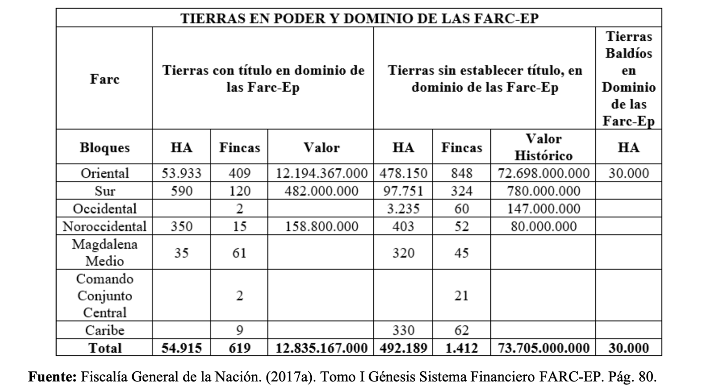
Chart taken from (Pedraza-Piñeros, 2019, p. 33)
FARC strategic dispossession is the landscape where current deforestation and land grabbing takes place. As stated by the Attorney’s office there are half of million hectares under investigation related to guerrilla´s strategy to seize lands overlaying deforestation hotspots. However, after the Peace process there are more actors promoting road expansion and livestock infrastructure to step up production. Land use change connected with deforestation, conversion to pastures and ultimately land grabbing behaves differently according to historical, social and ecological context. For that purpose, using deforested patches between 2020 and 2021 and the 26 variables related to environmental (See Annex 2), social, economic, and armed conflict conditions in the Northwestern Arc of the Colombian Amazon, 5 areas were classified using the unsupervised classification algorithm "K-means" (Figure 1). In each zone, the similarity between the average values of the variables associated with the patches and their geographic proximity allows for quantitative outputs and geographic representation and facilitates analyzing forest cover loss and local conditions to demonstrate land grabbing in relation to the conversion to pastures and deforestation. In the following map is the study area and the points show deforestation patches. Color points shows the patters of land grabbing that were differentiated in five zones as follows.
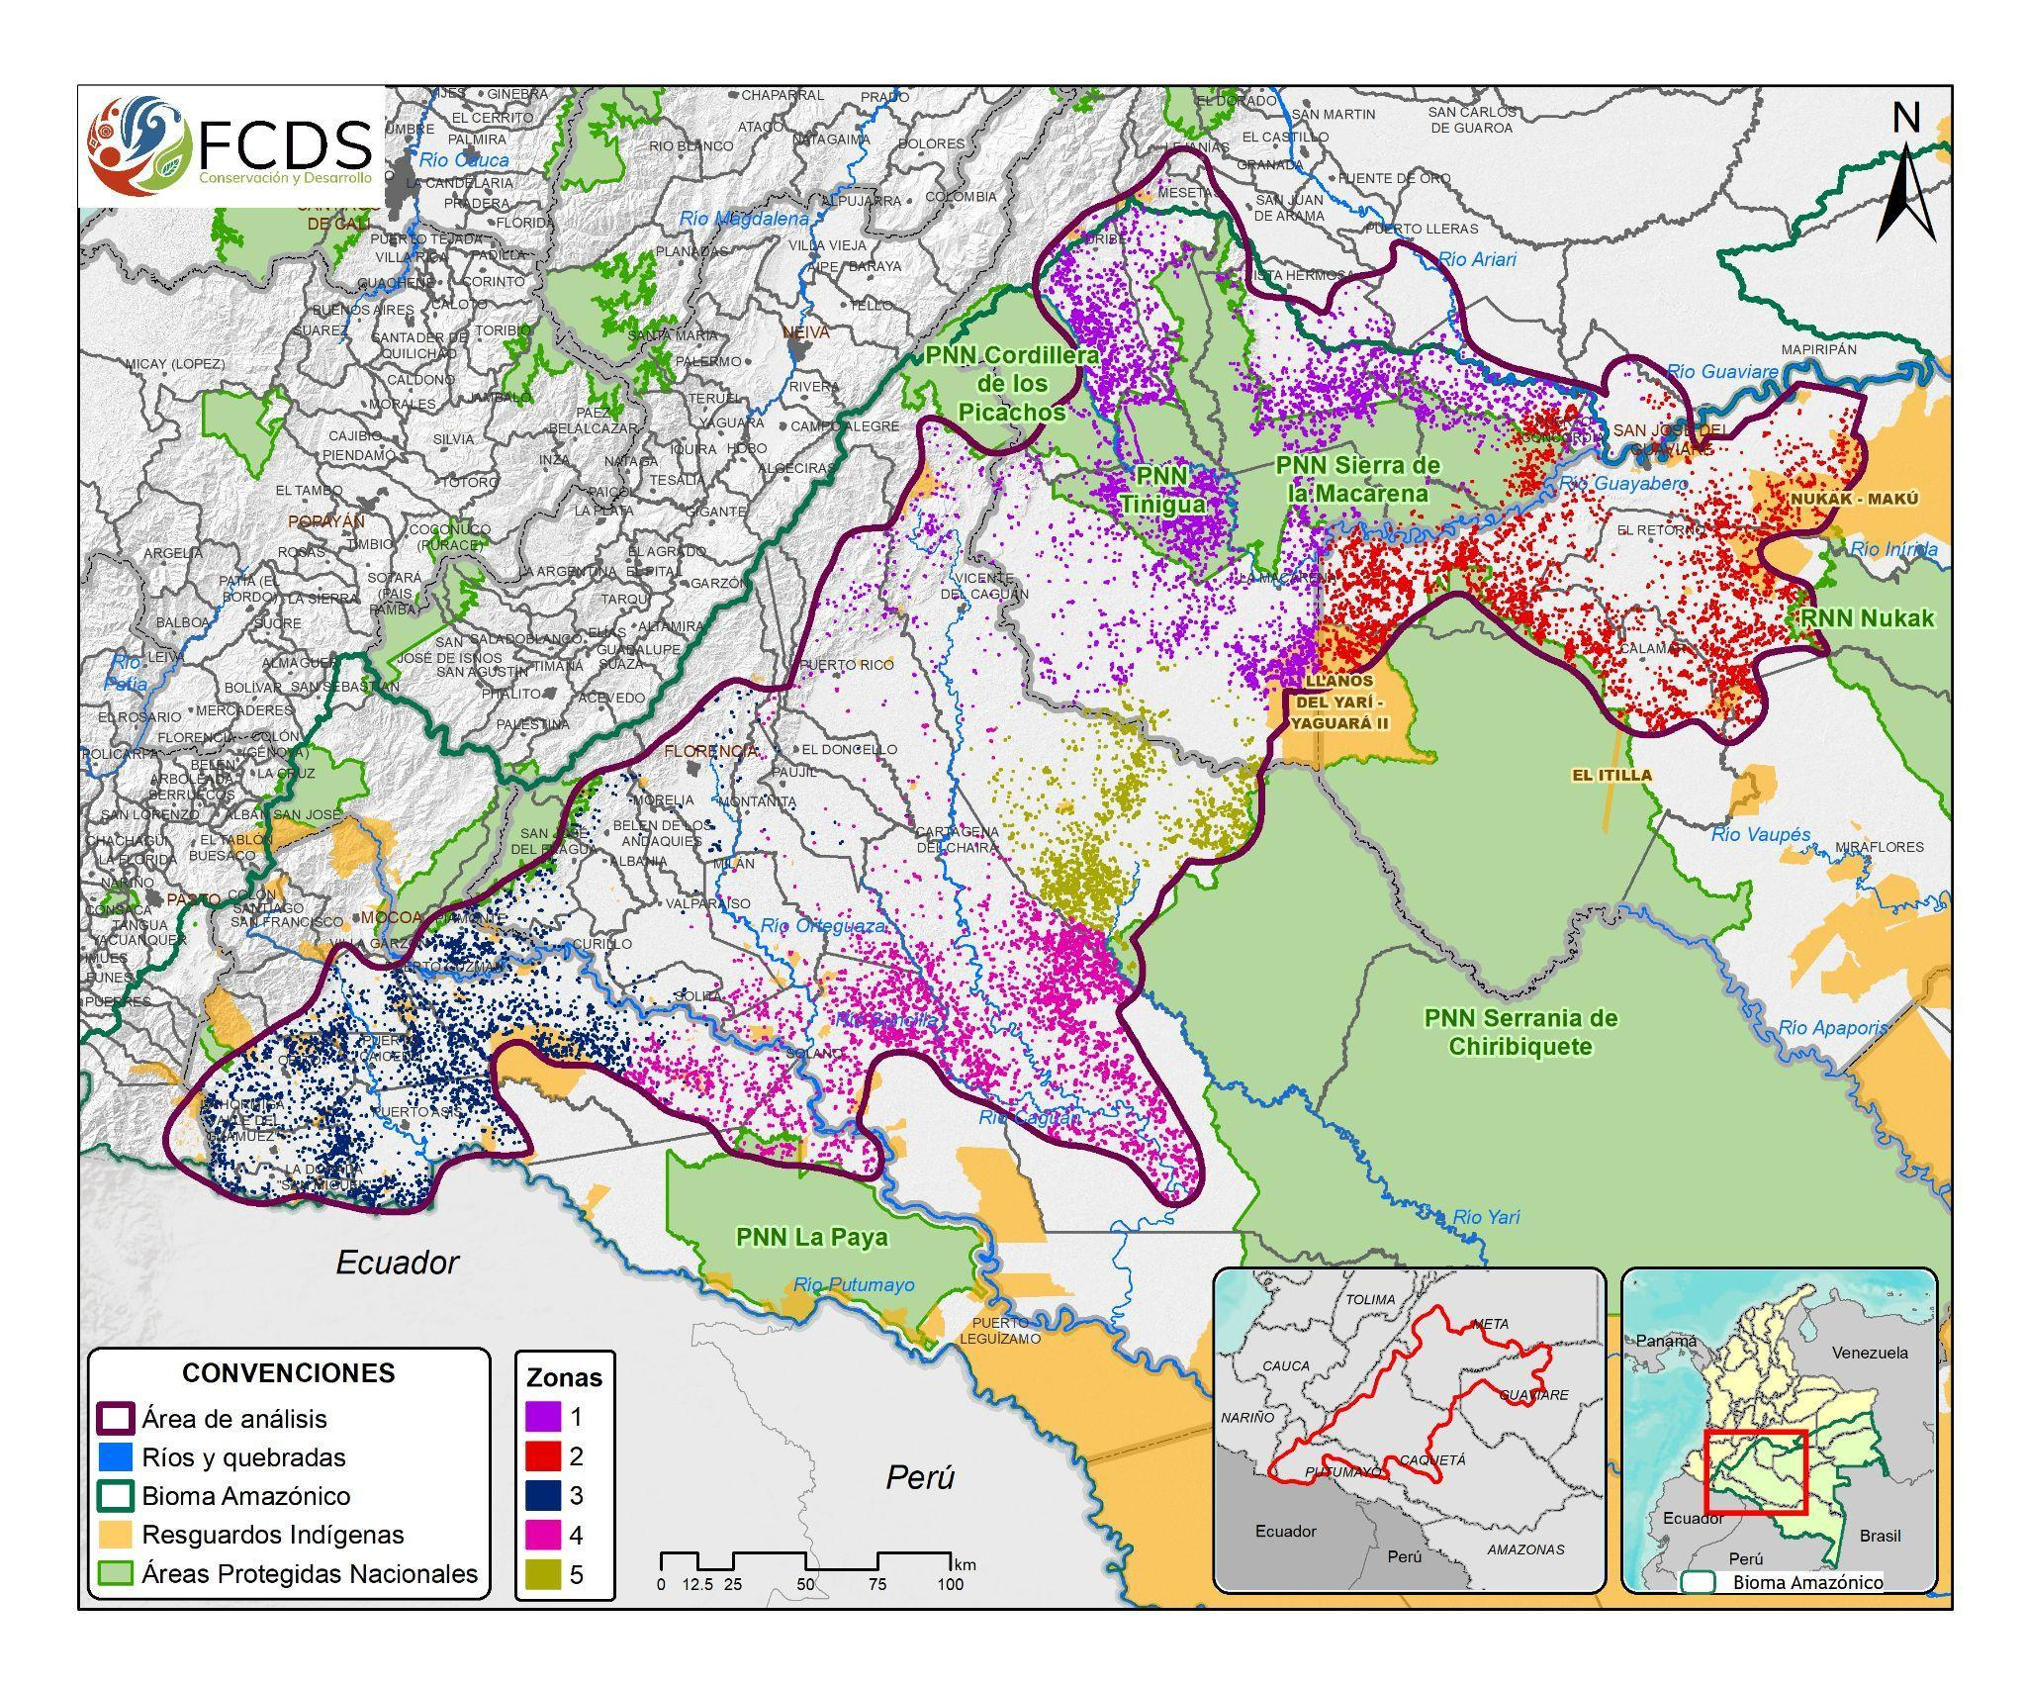
Figure 1. Classification by zones using the "K-means" algorithm based on deforested patches from 2020 to 2021 and variables related to environmental, social, economic and armed conflict conditions in the Northwestern Arc of the Colombian Amazon, elaborated by FCDS, 2022
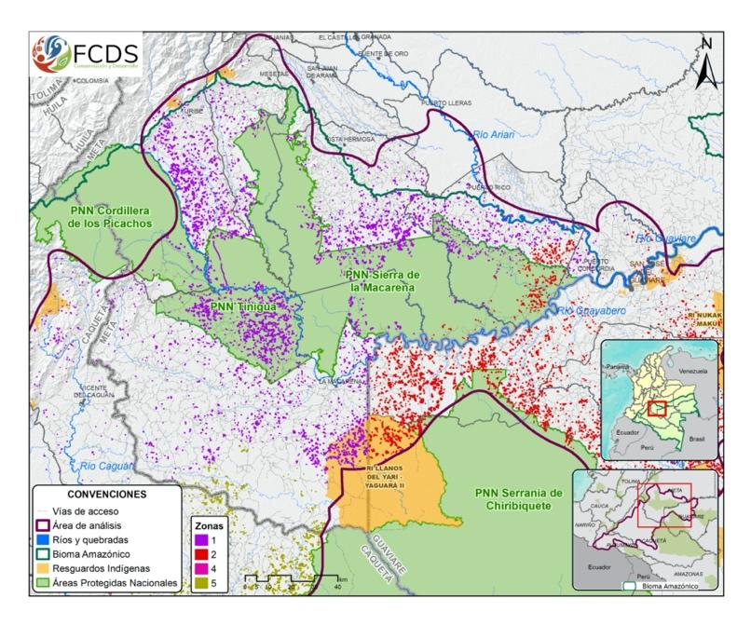
Zone 1: The deforested patches in this area in 2020-2021 period have an average area of 4.8 ha and are part of the municipalities of Uribe, Mesetas, Vistahermosa, Puerto Rico, and La Macarena (Meta). In this zone, the presence of illicit coca crops has been a constant within the Sierra de la Macarena PNN with an average planting area of 1 ha and with higher crop densities at 5-16 ha/km2 (UNODC 2022). A broad view of the department of Meta establishes a strategic location for drug trafficking and chemical supplies, with road connections to the center of the country and through the Guaviare and Guayabero rivers, connecting with the Amazon and Orinoquía regions. Hence, the data obtained for this area shows that patches deforested last year have an average distance of 20 km from population centers, 5 km from the agricultural frontier, 10 km from navigable rivers, and less than 1.8 km from the road infrastructure. These characteristics may explain the strategic importance that this area had for the FARC connecting the Amazon with the plains. This area has been a strategic point not only for the permanence and growth of illicit coca crops, but also for other illicit economies such as timber trafficking and mining that create a diverse financial portfolio that has led to territorial disputes. This explains why this area today has the highest density of antipersonnel landmines in the northwestern arc of the Amazon (1.33). Vista Hermosa, Meta is the largest municipality with land mine victims nationwide.
Zone 1 Map
The profitability of illicit coca cultivation in this area is explained by using more productive varieties, with yields between 6.9 and 8.4 ton/ha/year (UNODC 2022). However, the Multidimensional Poverty Index average for this area of study (58.86) reflects the challenging socio-economic situation relying on low income, scarce public services supply and poor housing quality. The conditions of vulnerability in the territory make easier to find workers to slash and burn, harvest coca, or work as illegal miners as a mechanism of survival (Arias and Duica, 2022).
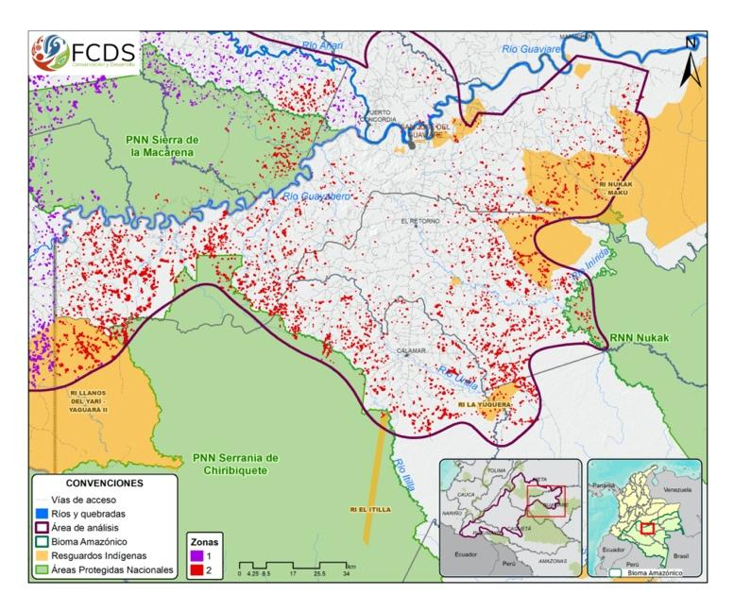
Zone 2: It includes deforestation patches from 2020 to 2021 located in the municipalities of Puerto Rico and Vistahermosa (Meta), San José del Guaviare, Calamar, El Retorno, and Miraflores (Guaviare). The average size of each deforested patch is 5.1 ha. This study area shows maximum values of victims of violence with a municipal average of 19,465 victims 2001-2016 prior to the signing of the peace agreement with FARC, and 945 after signing. In early 2000, the territory experienced a strong wave of violence where forced displacement was seen to a greater degree in the Northeastern areas of the Serranía del Chiribiquete PNN and the Nukak-Maku Indigenous Reservation. The presence of illicit coca crops continues to be a constant in the study area, with an average area of 1.8 ha; however, planted areas of more than 8 ha can be found with high densities in the jurisdiction of the Nukak-Maku Indigenous Reserve and Reservation, approximately 5-16 ha/km2 (UNODC 2022). The municipalities most affected by illicit coca crops are San José del Guaviare, El Retorno, and Miraflores, concentrating close to 70% of the harvested area in 2021 for the Meta-Guaviare region (UNODC, 2022).
In general, 87% of coca producers reach the point of producing basic coca paste that later is moved to La Macarena (Meta) where is transformed into cocaine hydrochloride (UNODC 2022, FCDS, 2022). It is estimated that by 2021, for each ton of coca leaf, an average of 1.8 kg of basic paste is obtained, which represents a 33% increase in production yield compared to what was registered in 2013 (1.41 kg/tm) (UNODC 2022). In this sense, significant mobility corridors of illegal economies have been established in territories under the control of illegal armed groups, of which the following stand out: i) Puerto Cachicamo-La Macarena, where the recent development of road infrastructure around old roads has affected the Llanos del Yarí-Yagurá II Indigenous Reservation triggering forced displacement, appropriation of reservation lands cleared to install cattle ranches leading to appropriation. ii) La Paz-Nueva-Barranquillita, known for being a front for current colonization and the expansion of the agricultural frontier, with strong deforestation processes and land occupation dynamics, its geographical location has been crucial in moving supplies to process coca, cocaine base, and livestock, through the Inírida river. iii) Tomachipan-Charras, this corridor crosses the Nukak-Maku Indigenous Reservation, with ports connecting the Inírida River with the Guaviare River, and the cattle trail with San José del Guaviare. From 2015 to 2021, 461,278 ha of the reservation have been deforested. On the reservation, 31 villages (veredas) have been established, that have been transformed into pastures where active cattle ranching is taking place. Just in 2022, ICA recorded the mobilization of 22,626 bovines from the Nukak reservation (ICA, 2022). The social, environmental, and cultural impact of the reservation is one of the effects of appropriation, deforestation, and conversion to pastures. iv) Barranquillita-Miraflores, as of 2016 with FARC demobilization, colonization and land appropriation have intensified in this sector aiming land grabbing for cattle ranching and illicit coca crops. In these areas there are disputes over territory and economic control by FARC dissidents.
Zone 2 Map
The results of the logistic model reiterate road infrastructure development as a condition that favors deforestation and land grabbing, since it is 6 times more likely that forest loss will occur in areas close to 1 km of roads compared to those located at over 5 km. High profitability of cocaine and livestock economies enhance developing road infrastructure which is one of the greatest predictors of deforestation. Deforested patches from 2020 to 2021 for this study area are on average less than 1 km away from roads, which is related to the increase in sub municipal illegal tertiary road, calculated only for Guaviare at 1,260 km from 2018 to March 2022 (FCDS 2022).
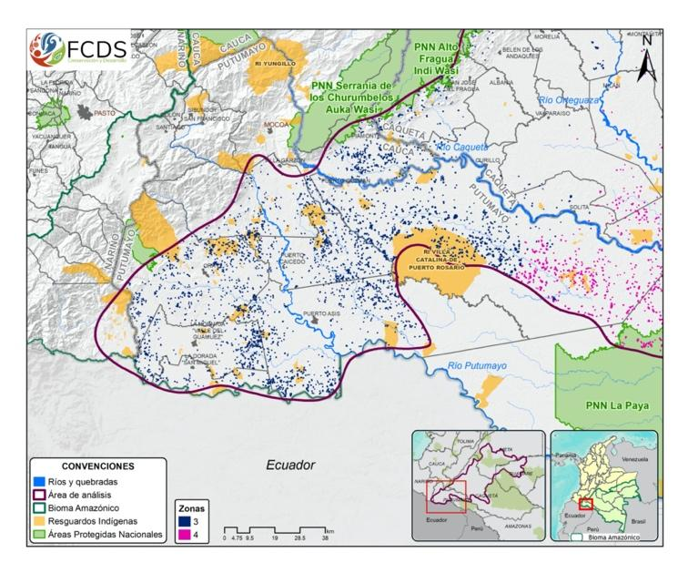
Zone 3: Includes deforestation patches from 2020 to 2021 located in the municipalities of Piamonte (Cauca), San José de Fragua, Curillo (Caqueta), Puerto Guzmán, Villagarzón, Mocoa, Orito, Valle del Guamez, San Miguel, Puerto Asís, and Puerto Caicedo (Putumayo). The average size of the deforested patch is 2.2 ha, the smallest of all the zones. This is related to the predominance of the coca driver of deforestation that allows transforming the forest cover into a fragmented ecosystem.
In this study area, the expansion and profitability of illicit crops starting in the 1990s generated territorial disputes between the FARC and paramilitaries. Concurrently, in the late 1990s, the government promoted the eradication of coca. Cocalero Marches were “forcefully voluntary”, promoted by the FARC (Ramírez, 2001). The demonstrations were one of the first triggers for violence escalation with paramilitary groups up to the mid-2000s. It is estimated that between 2001 and 2016, the municipal average number of victims of the armed conflict for this area was 15,594 people. Puerto Asís has been one of the most violent municipalities up to date. As of 2016, the power vacuum left by FARC triggered the territorial dispute between FARC dissidents and organized crime structures (Revelo-Rebolledo, 2019). COVID 19 facilitated the retaking of power by the various armed groups, through massacres and assassination of leaders who promoted the voluntary substitution of illicit crops. In this sense, coca production is the most influential condition to explain deforestation associated with land grabbing in this area, with a frequency of planted area for more than 10 years, with the most productive enclaves being the Putumayo Border and Orito-Vides, areas with the highest concentration of coca crops per square kilometer (25-73 ha/km2); together they represent 4.6% of the total national coca and 11% of the total coca in enclaves (UNODC 2022). As of 2021, 28,205 ha of illicit coca crops have been found in Putumayo, 1.4 times more coca than the previous year, with yields between 7.9 and 8.8 tons/ha/year, with a high percentage of lots in highly productive ages (46.2%) that provide a higher yield of coca leaf, which could result in profits approaching 147 million dollars per year (UNODC 2022).
Zone 3 Map
The high profitability of the illicit cocaine business, estimated at 81 cents of profit for every dollar, explains a second land grabbing condition related to controlling territory by means of violence, controlling the peasant and indigenous communities in the cultivation, processing, and sale of cocaine. Its impact on the ecosystem is a deforestation pattern in penetrating continuous forests that drives actors to colonize and monopolize land planted with coca, process it, and ensure greater profits. In this sense, deforested areas in the 2020-2021 period are characterized by having the shortest distance between populated centers and the agricultural frontier (8.5 km and 800 mt, respectively) in relation to the other areas analyzed, being 6 times more likely to be deforested at less than 1 km than at distances greater than 5 km from the agricultural frontier.
Other conditions that stand out in this area is the high presence of oil infrastructure and mining titles, where the areas deforested between 2020 and 2021 have an average distance of 5.7 km for oil fields and 13 km for mining titles. Cocaine processing requires a large number of chemical supplies such as gasoline, potassium permanganate, and sulfuric acid, which are acquired through border smuggling and artisanal processing. It is estimated that almost 99% of the liquid substance associated with cocaine hydrochloride production is gasoline, obtained mostly in Putumayo through the illegal drilling of the trans-Andean pipeline. This shows a match in the areas with illicit crops along the pipeline’s infrastructure. Although livestock is found in this area, the municipal cattle census for 2020 is 26,116 heads on average, the lowest amount compared to other zones.
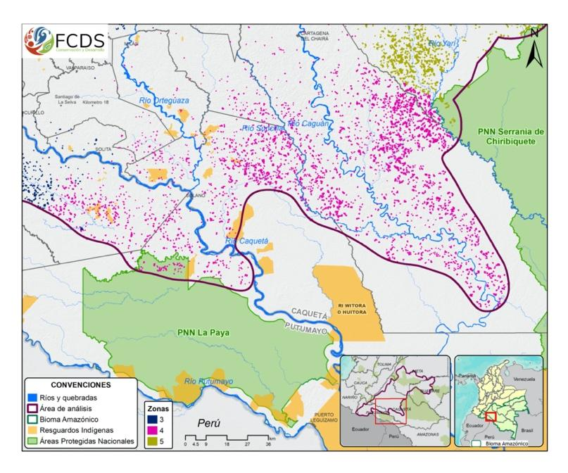
Zone 4: The deforested patches in this area in 2020-2021 period have an average area of 6.6 ha and are part of the municipalities of Cartagena del Chaira (Caquetá), Solano (Caquetá), and Puerto Guzmán (Putumayo), and to a lesser extent San Vicente del Caguan, La Montañita (Caquetá), and Puerto Leguízamo (Putumayo). The area has two dynamics: one to the north of the Caguan River, in the jurisdiction of Cartagena del Chairá, where there are deforestation patches of 9.1 ha associated with cattle ranching, and another to the south of the Caguan River involving coca crops with deforestation patches of 5.1 ha in the jurisdiction of the municipalities of Solano, Puerto Guzmán, and Puerto Leguízamo.
Zone 4 Map
This area is an ecological corridor between southern Chiribiquete PNN (Caquetá) and the La Paya PNN (Putumayo), which is connected by the Caquetá and Caguan rivers. This strategic ecosystem is strongly affected by deforestation, where 55% of deforested patches (12,312 ha) are on the Amazon Forest Reserve Zone, and 44% (9,945 ha) are on areas removed from the Reserve. This area was the connection point between the former Eastern and Southern Blocs of FARC guerrilla given the importance of this area as a strategic corridor with easy fluvial connection.
After zone 5, the second most significant cattle population at the national level is found in this zone, where in 2022 there are 695,670 livestock, mainly in Cartagena del Chaira. Livestock is located in two areas with the highest densities of fire events from 2016 to 2021 in the study area: The first, found between the Caguan River and the Cuemaní River. The second, found between the Caguan River and the Suncilla River. Therefore, rivers in this area are used to transport cattle, generally throughout the Caguán river to Puerto Rico (Caquetá) and by the Orteguaza River to Florencia (the capital of Caquetá), located at a 100 km from urban areas. Therefore, there is no strong relationship between roads and deforestation, since the main means of communication are rivers, located on average 6.9 km away from deforested areas for the period analyzed.
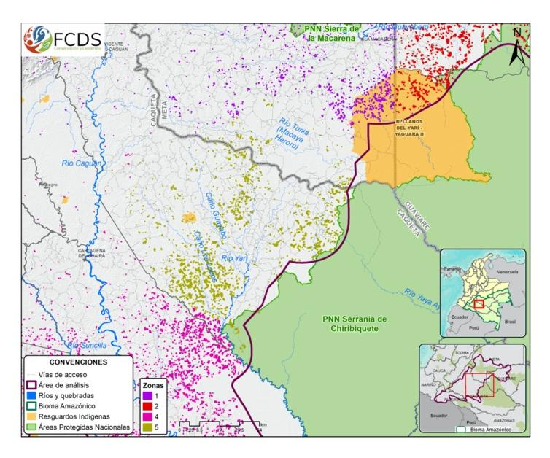
Although the average area accumulated in coca (0.95 ha) and the average frequency (0.49 years of persistence) for this zone are not the highest in the study area, coca crops are evident in the lower part of the Caquetá river associated with deforested patches. Although cocalero influence in land grabbing is more associated with zone 3, both the illicit drug economy and cattle ranching maintain an influence on land occupation and conversion to pastures. However, for this area, multidimensional poverty index is the highest compared with the other study areas, with 63.9% of people having low income, low public health coverage, and poor housing, and education services. In addition, the Unsatisfied Basic Needs Index is 38.7 and it is estimated that 11.8% of the population is destitute. The municipality also has a Development Index of 45.5, the lowest in the entire study area. This shows the low level of progress in the municipality in social, economic, and institutional dimensions. In general, this is the area has the worst living conditions in the entire study area.
Zone 5: The 2020-2021 deforested patches in this area are found on the western borders of the Chiribiquete PNN, mainly in the municipality of San Vicente del Caguan (Caquetá). The average size of the deforested patch in the study period is 10.3 ha. It is the area with the largest patches in the study area. The dominant driver in this zone is cattle ranching with a pattern of deforestation associated to conversion to pastures.
San Vicente del Caguán has had FARC presence since the 1960s maintaining social and military hegemony, controlling the territory and the economy. During the 1998-2002 peace negotiation, this area was part of the "demilitarized zone", where the guerrillas bolstered their military strength and appropriated more than 150,000 hectares of land. After the agreements broke down, confrontations over territorial disputes with the Armed Forces escalated, increasing the number of victims affected by antipersonnel mines, mainly military and police (Duica-Amaya, 2022). The acts of violence affected the civilian population (threats, murders, attacks on infrastructure, and forced recruitment), where approximately 11,402 victims of the armed conflict were registered between 2001 and 2016 in the municipality, one of the highest in the country. After 2016, there are new illegal actors associated with organized crime structures as well as FARC dissidents that illegally appropriated land and consolidate land grabbing (Verdad abierta 2015, Consejo de redaccion, 2016 and El Tiempo, 2013).
Zone 5 Map
Although the government's efforts have focused on recovering public lands appropriated by illegal actors and on seized assets, documentation on land ownership is almost non-existent. It is estimated that 97,928 ha were irregularly legalized by registering public land titling without meeting full legal requirements. As mentioned, FARC´s Eastern bloc strategy was to seized large areas in the southeast region of the country, launder money through intermediaries, and consolidating a mobility corridor (Verdad abierta 2015, Consejo de redacción, 2016 and El Tiempo, 2013).
In San Vicente del Caguán cattle ranching skyrocketed in 2022 with 909,364 cattle and one of the highest forest losses at national level recorded for 2016-2022 with 105,659 ha. As of 2022, it is the municipality with the highest number of early deforestation warnings at national level (21.1% of the national total), and it is the second municipality in the country with the highest number of fire warnings from January to February 2022 (3,808). Fire is commonly used as a practice for clearing and managing pastures. Currently, it facilitates clearing forests, cattle ranching expansion, and land grabbing. The deforested patches in this area from 2020 to 2021 have an average distance of 53 km from population centers. It is the area with the longest average distance to the agricultural frontier (8.6 km) and in relation to the other zones, it is 2 km on average from roads, mostly illegal, to mobilize cattle. San Vicente del Caguán today is one of the municipalities with the highest livestock production nationwide.
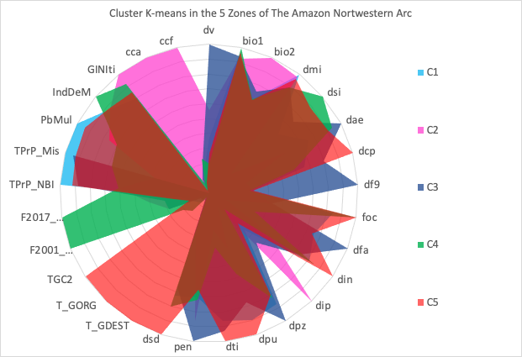
*Detailed figures of each zone and dictionary of variables can be found in Annex 2.

Recommendations
To halt deforestation recommendations must be focus in the following 5 areas with the highest deforestation: 1) San José del Guaviare (North of the Serranía de Chiribiquete PNN, in the municipality), 2) Nukak Makú indigenous reservation (Eastern border on the road that connects the La Paz district with Nueva Barranquillita and the road that leads from Calamar to Miraflores in the municipality of El Retorno, Guaviare). 3) The Camuya River sector of influence, (eastern border of the Serranía de Chiribiquete PNN), 4) The Amazonia – Andes connectivity corridor between the Chiribiquete PNN and 5) the Macarena PNN (it is more endangered than ever in the area closest to forests).
Cadastral formation and updating (IGAC): Carry out partial cadastral formation, giving priority to areas where the agricultural frontier is expanding in the critical hotspots: Nukak - Makú IR, eastern flank of Chiribiquete NP, borders of Yaguará IR, Tinigua NP, Macarena natural park, lower Caguán - South of the Yarí Savannas and border of Paya natural park. The approach to cadastral updating in Colombia has always been for fiscal purposes. In this case the national government must set the priority to establish the cadaster in these areas. At the same time, Ministry of agriculture (Agencia Nacional de Tierras-ANT) must update the information the public lands inventory (ANT) connected with registry information, IGAC, SNR and ministry of interior.
Municipality majors must control new sub municipal areas (veredas) in highly deforested areas. Establishing new Community Action Boards in areas with deforestation connected to land grabbing facilitates the certification of those farms to legally establish livestock production allowing a façade of legality. The community boards request to the municipalities the legalization of new Veredas in areas contiguous or overlapped with protected areas, indigenous reservations, or forest reserves. As the municipality is the administrative planning authority, the control authorities (Ombudsmand Office and Comptrollers Office) must investigate the creation of new veredas in highly deforested areas.
The national government and the congress must pass new legislative initiatives to strengthen the framework to fight against environmental crimes associated to deforestation, conversion into pastures and land grabbing. On December the 1st 2022 the Constitutional Court declared unconstitutional the crimes of illegal appropriation of public lands and financing deforestation under the Law 2711/2021. These tools were important to investigate and prosecute the structures of those responsible for appropriation, deforestation and land grabbing.
Traceability along the supply chains is important to map key stakeholders acting as front men of criminal networks to facilitate money laundering. Attorney’s office should analyze deforestation as an environmental crime macro case. The main challenge to investigate deforestation connected with land grabbing is the informality in the supply chains of cattle byproducts that are trade with no restrictions within the country. For that reason, it is recommended that the National Government, through its Ministries of Environment and Agriculture, create a robust livestock traceability system to monitor livestock in protected areas. This system should be based on at least 4 main pillars: i) Vaccination and mobility information from ICA, ii) Deforestation information from IDEAM's Forest and Carbon Monitoring System, iii) Cadastral information from IGAC and iv) Notary and registry information from SNR.
Majors and governors of high deforestation municipalities must stop providing buying incentives to purchase animals and financing productive infrastructure associated with the fattening of cattle for meat and milk production (corrals, water reservoirs, fences, livestock genetic improvement) in high deforested areas. Likewise, the Ministry of Agriculture (Finagro and Banco Agrario) must assess if the farming credits will be used in livestock production in deforested areas.

Generating sustainable development opportunities in the region and not only seasonal employment. Mitigating deforestation requires fighting multidimensional poverty and the lack of goods and services to make territories sustainable. Deforestation associated to livestock or raspachin work in the coca economy require abundant unskilled labor and becomes a mechanism of survival in areas with high deforestation. For this reason, fighting deforestation also entails improving employment conditions and well-being of the population. This is a joint responsibility beginning with the major of every municipality, the national entities to promote better goods and service delivery but also implies the private sector.

Source: IDEAM 2021

Bibliografía
Acero, C., Prada, M. (2019). ¿De eso bueno no dan tanto? La experiencia colombiana en formalización de tierras a la luz de la evidencia internacional. Análisis político (95); Universidad Nacional de Colombia
Aguilera, M. (2013). Las FARC: Auge y quiebre del modelo de guerra. Análisis Político, 77(enero-abril), 85–111. https://revistas.unal.edu.co/index.php/anpol/article/view/44005/45253
Arias, Enrique D y Duica-Amaya, Liliana (2022) Advocacy, Misdirection, Protest, and Exit: Strategies of Aspiration and Anxiety amid Crime and Conflict in Putumayo. Latin American Politics and Society. Cambridge University Press. Disponible en: https://www.cambridge.org/core/journals/latin-american-politics-and-society/article/abs/advocacy-misdirection-protest-and-exit-strategies-of-aspiration-and-anxiety-amid-crime-and-conflict-in-putumayo/3ECBDB6892BA6FA29174F609A1B7E968
Asher, Claire La tolerancia cero con la deforestación podría ser la única forma de salvar el acceso al Amazonas, Diciembre 15, 2017 Disponible en: https://es.mongabay.com/2017/12/la-tolerancia-cero-la-deforestacion-podria-la-unica-forma-salvar-acceso-al-amazonas/
Barton, Jonathan R. (2009). Adaptación al cambio climático en la planificación de ciudades-regiones. Revista de geografía Norte Grande, (43), 5-30. https://dx.doi.org/10.4067/S0718-34022009000200001
Benedict, M. A., & McMahon, E. T. (2002). Green infrastructure: smart conservation for the 21st century. Renewable resources journal, 20(3), 12-17.
Borras, S.M., Kay, C., Gómez, S., Wilkinson, J. (2013). Acaparamiento de tierras y acumulación capitalista: Aspectos clave en América Latina. Revista Interdisciplinaria de Estudios Agrarios, 38. URL: r1.ufrrj.br/geac/portal/wp-content/uploads/2012/11/BORRAS-et-al-Acaparamiento-de-tierras-y-acumulaciu00F3n-capitalista-2013.pdf
Brücher, W. (1968). La Colonización de la selva pluvial en el piedemonte amazónico de Colombia. El territorio comprendido entre el río Arari y el Ecuador.
BUR 3, IDEAM, Fundación Natura, PNUD, MADS, DNP, CANCILLERÍA. (2021). Tercer Informe Bienal de Actualización de Colombia a la Convención Marco de las Naciones Unidas para el Cambio Climático (CMNUCC). IDEAM, Fundación Natura, PNUD, MADS, DNP, CANCILLERÍA, FMAM. Bogotá D.C., Colombia.
Clerici, N., Armenteras, D., Kareiva, P., Botero, R., Ramírez-Delgado, J. P., Forero-Medina, G., Ochoa, J., Pedraza, C., Schneider, L., Lora, C., Gómez, C., Linares, M., Hirashiki, C., & Biggs, D. (2020). Deforestation in Colombian protected areas increased during post-conflict periods. Scientific Reports, 10(1), 1–10. https://doi.org/10.1038/s41598-020-61861-y
Corte Constitucional. Ley 2111 de 2021. Capítulo V- Artículo 377: Apropiación ilegal de baldíos de la nación. URL: https://www.funcionpublica.gov.co/eva/gestornormativo/norma.php?i=167988
Consejo de redacción (2016) Un viaje al corazón de las tierras de las Farc. Disponible en: https://consejoderedaccion.org/noticias/un-viaje-al-corazon-de-las-tierras-de-las-farc
Dávalos, L. M., Davalos, E., Holmes, J., Tucker, C., & Armenteras, D. (2021). Forests, Coca, and Conflict: Grass Frontier Dynamics and Deforestation in the Amazon-Andes. Journal of Illicit Economies and Development, 3(1), 74–96. https://doi.org/10.31389/jied.87
Dávalos, L. M., Holmes, J. S., Rodríguez, N., & Armenteras, D. (2014). Demand for beef is unrelated to pasture expansion in northwestern Amazonia. Biological Conservation, 170, 64–73. https://doi.org/10.1016/j.biocon.2013.12.018
Duica, Liliana. La tenencia de la tierra en la Amazonia colombiana, FCDS, Amazonía revelada [forthcoming publication]
Duica-Amaya, L. (2020). Paisajes minados en Colombia: los artefactos y su vida natural, social y técnica [Ph.D Thesis]. Los Andes.
Duica-Amaya, Liliana y Salas Pérez, Cristian (2022) Entre la conservación “a punta de bala” y la deforestación: dinámicas en las gobernabilidades híbridas en la Amazonía Colombiana. En Uribe, Simon y Rebelo, Javier “Complejizando la deforestación amazónica: trayectorias nacionales, conflictos y alternativas” Universidad del Rosario.
EIA (2021) Tainted beef: How criminal cattle supplies are destroying the Colombian Amazon. Disponibe en: https://us.eia.org/report/20210527-tainted-beef-report/
El Tiempo (2013) Así se adueñaron las Farc de la tierra en el Caguán. Disponible en: https://www.eltiempo.com/archivo/documento/CMS-12615401
Fajardo, D. (1996). Fronteras, colonizaciones y construcción social del espacio. In C. Caillavet & X. Pachón (Eds.), Frontera y poblamiento: estudios de historia y antropología de Colombia y Ecuador (pp. 237–282). Instituto Francés de estudios andinos.
Fajardo, J. (2019, November 5). Disidencias de Farc y sus “reglas” en zonas rurales. El Colombiano. Disponible en https://www.elcolombiano.com/colombia/disidencias-de-farc-y-sus-reglas-en-zonas-rurales-LB11892786
FARC. (n.d.). Manual de convivencia Estado mayor frente combatientes del Yarí, Bloque Oriental.
FCDS-Unidos por los bosques-Embajada del Reino de Noruega, Monitoreo de pérdida de cobertura vegetal enero - febrero 15 de 2022. Disponible en: https://fcds.org.co/wp-content/uploads/2022/07/boletin-deforestacion.pdf
FCDS, Fundación para la Conservación y el Desarrollo Sostenible (2022a). Seguimiento de la pérdida de bosques y cambio de cobertura en el arco de deforestación en la Amazonia Colombiana (Abril 2021-Marzo 2022), Bogotá, Colombia.
FIP. (2015). Hoy y ayer del bloque oriental de las FARC.
Forman, R.T., Godron, M. 1986. Landscape Ecology. New York: John Wiley and Sons.
Geist, H.J., Lambin, E.F. 2002. Proximate Causes and Underlying Driving Forces of Tropical Deforestation: Tropical forests are disappearing as the result of many pressures, both local and regional, acting in various combinations in different geographical locations. BioScience, 52: 143-150.
Gentry, J. A., & Spencer, D. E. (2010). Colombia’s FARC: A portrait of insurgent intelligence. Intelligence and National Security, 25(4), 453–478. https://doi.org/10.1080/02684527.2010.537024
Global Forest Watch, Alertas de incendio Caquetá. Disponible en: https://www.globalforestwatch.org/dashboards/country/COL
Gómez Zuñiga, Sebastián (2018) La ecología política de las FARC-EP: Un análisis de las territorialidades, prácticas y discursos de la insurgencia frente a la naturaleza. Tesis maestría Universidad Javeriana. Disponible en: https://repository.javeriana.edu.co/handle/10554/36554
González, J. Cubillos, A., Chadid, M., Cubillos, A., Arias, M., Zúñiga, E., Joubert, F. Pérez, I, Berrío, V. Caracterización de las principales causas y agentes de la deforestación a nivel nacional período 2005-2015. (2018). Instituto de Hidrología, Meteorología y Estudios Ambientales – IDEAM-. Ministerio de Ambiente y Desarrollo Sostenible. Programa ONU-REDD Colombia. Bogotá. URL: http://documentacion.ideam.gov.co/openbiblio/bvirtual/023780/Caracterizacion.pd
Helmut J. Geist, Eric F. Lambin. (2002). Proximate Causes and Underlying Driving Forces of Tropical Deforestation: Tropical forests are disappearing as the result of many pressures, both local and regional, acting in various combinations in different geographical locations, BioScience, Volume 52, Issue 2, Pages 143–150, https://doi.org/10.1641/0006-3568(2002)052[0143:PCAUDF]2.0.CO;2
Hernández, F. et al. (2021). Gobernanza transparente de los recursos naturales en Colombia. USAID & WWF. URL: https://files.worldwildlife.org/wwfcmsprod/files/Publication/file/38g4v7obkf_Reporte_Final_TGNR.pdf
ICA, Resolución No. 090464 de 20 de enero de 2021 y Resolución No.00007067 del 2 de mayo de 2022. “Por la cual se establecen medidas encaminadas a la cancelación del Registro Sanitario de Predio Pecuario- RSPP de los predios que desarrollen su actividad ganadera de Bovinos y/o Bufalinos dentro de las áreas del Sistema de Parques Nacionales Naturales, Parques Naturales Regionales del país. Disponible en: https://www.ica.gov.co/getattachment/38fe2f94-6646-4f7e-96d5-117f95e29c3a/2022R0007067.aspx

Hernández, F. et al. (2021). Gobernanza transparente de los recursos naturales en Colombia. USAID & WWF. URL: https://files.worldwildlife.org/wwfcmsprod/files/Publication/file/38g4v7obkf_Reporte_Final_TGNR.pdf
IDEAM (2022). Sistema de Monitoreo de Bosques y Carbono, Resultados del monitoreo a la deforestación años 2013-2021, Bogotá, Colombia.
In Sight Crime & IGARAPÉ. (2022). La Amazonía saqueada: Las raíces de los delitos ambientales en cinco países. URL: https://es.insightcrime.org/investigaciones/amazonia-saqueada-raices-delitos-ambientales/
IPBES 2019, Global assessment report of the Intergovernmental Science-Policy Platform on Biodiversity and Ecosystem Services, Brondízio, E. S.,
IPCC, 2022: Summary for Policymakers [H.-O. Pörtner, D.C. Roberts, E.S. Poloczanska, K. Mintenbeck, M. Tignor, A. Alegría, M. Craig, S. Langsdorf, S. Löschke, V. Möller, A. Okem (eds.)]. In: Climate Change 2022: Impacts, Adaptation and Vulnerability. Contribution of Working Group II to the Sixth Assessment Report of the Intergovernmental Panel on Climate Change [H.-O. Pörtner, D.C. Roberts, M. Tignor, E.S. Poloczanska, K. Mintenbeck, A. Alegría, M. Craig, S. Langsdorf, S. Löschke, V. Möller, A. Okem, B. Rama (eds.)]. Cambridge University Press, Cambridge, UK and New York, NY, USA, pp. 3–33, doi:10.1017/9781009325844.001.
Li, H., Wu, J. 2007. Landscape pattern analysis: key issues and challenges. En J. Wu, R.J. Hobbs (eds.), Key topics in landscape ecology (pp. 39-59). Cambridge UK: Cambridge University Press.
Lizarazo, María Paula, Lo que pasa cuando perdemos la conectividad entre la Amazonia y los Andes. Disponible en: https://www.elespectador.com/ambiente/amazonas/estamos-perdiendo-la-conectividad-entre-el-amazonas-y-los-andes/
Mantyka-Pringle, C. S., Visconti, P., Di Marco, M., Martin, T. G., Rondinini, C., & Rhodes, J. R. (2015). Climate change modifies risk of global biodiversity loss due to land-cover change. Biological Conservation, 187, 103-111.
Margin, G. (2015). Estudios del cambio climático en América Latina. Adaptación al cambio climático en América Latina y el Caribe. CEPAL y Unión Europea.

Ministerio de Ambiente y Desarrollo Sostenible, Facultad de Estudios Ambientales y Rurales, Pontificia Universidad Javeriana, Instituto Alexander von Humboldt, Cooperación Técnica Alemana GIZ, Departamento Nacional de Planeación. (2012). Política Nacional para la Gestión Integral de la Biodiversidad y sus Servicios Ecossitémicos. Bogotá, D.C., Colombia. URL https://www.minambiente.gov.co/index.php/bosques-biodiversidad-y-servicios-ecosistematicos/politica-nacional-de-biodiversidad/generalidades-politica
Molano, A. (1997). Selva adentro. Una historia oral de la colonización del Guaviare (4ta ed.). Áncora Editores.
Molinares, Cesar, La deforestación tras la carne que comemos en Bogotá. Febrero 28 de 2022 y El ganado acorrala a la Amazonía. Noviembre 24 de 2021. 360 grados. Disponibles en: https://360-grados.co/investigaciones/54-el-ganado-acorrala-a-la-amazonia
Moreno-Martínez, Ó. D. (2021). Military and health innovations in clandestine warfare settings. Technical specialization and collective resourcefulness in the FARC-EP [Ph.D Dissertation]. The University of Edinburgh.
Muhamad, Susana (2022) Ministra de Ambiente. Boletín cifras de deforestación del Ministerio de Ambiente. Bogotá D.C., 7 de septiembre
Oxfam (2013) Divide y comprarás: Una nueva forma de concentrar tierras baldías en Colombia. Informes de investigación de Oxfam. URL: https://www-cdn.oxfam.org/s3fs-public/file_attachments/rr-divide-and-purchase-land-concentration-colombia-270913-es_0.pdf
Pecaut, D. (2008). FARC una guerrilla sin fin o sin fines (1st ed.). Gupo Editorial Norma.
Pedraza-Piñeros, D. (2019). Despojo de tierras en contexto de guerra irregular: el caso de las FARC-EP entre 1992 y 2015 [BA Theses]. Universidad Javeriana.
Ramirez, M. Clemencia (2001) Entre el Estado y la Guerrilla. ICANH.

Pascual, U., Balvanera, P., Christie, M., Baptiste, B., González-Jiménez, D., Anderson, C.B., Athayde, S., Chaplin-Kramer, S., Jacobs, S., Kelemen, E., Kumar, R., Lazos, E., Martin, A., Mwampamba, T.H., Nakangu, B., O'Farrell, P., Raymond, C.M., Subramanian, S.M., Termansen, M., Van Noordwijk, M., Vatn, A. (eds.). (2022). IPBES. Summary for policymakers of the methodological assessment of the diverse values and valuation of nature of the Intergovernmental Science-Policy Platform on Biodiversity and Ecosystem Services. DOI: https://doi.org/10.5281/zenodo.6522392

Proyecto de Monitoreo de los Andes Amazónicos. MAAP #158: Deforestación y Fuegos en la Amazonía 2021. Disponible en: https://www.maaproject.org/2022/amazonia-deforest-fuegos-2021/

Rutas el conflicto (2022) vías sin resguardo. Disponible en:https://rutasdelconflicto.com/especiales/carreteras_resguardo_nukak/

Salgado Ruiz, H. (2012). El campesinado de la Amazonia colombiana : Construcción territorial, colonización forzada y resistencias. Universidad de Montreal.
Settele, J., Díaz, S., Ngo, H. T. (eds). IPBES secretariat, Bonn, Germany. 1144 pages. ISBN: 978-3-947851-20-1
SINCHI (2014). Informe final del análisis de motores, agentes y causas subyacentes de la deforestación para el área del “Proyecto de implementación temprana REDD en la Amazonia colombiana, localizado en el sector noroccidental del departamento del Guaviare y del área de referencia”.
Transparencia por Colombia. (2021). Documento interno de definiciones de los conceptos base de la Gobernanza Transparente de los Recursos Naturales.
Turner, M.G., Gardner, R.H., O'neill, R.V. 2001. Landscape ecology in theory and practice. New York: Springer.
UNODC, Oficina de las Naciones Unidas contra la Droga y el Delito. (2022). Sistema Integrado de Monitoreo de Cultivos Ilícitos (SIMCI), Monitoreo de territorios afectados por cultivos ilícitos 2021 Bogotá: UNODC-SIMCI.
UNODC, & NICFI. (2021). Fortalecimiento de las capacidades de las instituciones colombianas para luchar contra la deforestación -Evaluación integral-.
Urdaneta, J. S. (2017). Justicias bastardas: estudio sobre la administración de justicia de la guerrilla de las FARC en el suroriente colombiano. Universidad Nacional de La Plata.
UPRA (2019) Informalidad de La Tenencia de La Tierra En Colombia 2019.
USAID y WWF (2021) Gobernanza transparente de los recursos naturales en Colombia. Síntesis reporte final. Mecanismos para la materialización de la ocupación del territorio.
Vega, A. (2017). Concentración y extranjerización de tierras productivas en Colombia. Marco conceptual, legal e institucional, contribución a la aplicación de las Directrices voluntarias sobre la gobernanza responsable de la tenencia de la tierra. Bogotá: FAO.
Verdad abierta (2015) Un viaje al corazón de las tierras de las Farc. Disponible en: https://verdadabierta.com/especiales-v/2015/tierras-caqueta/
Wiens, J.A. 2002. Central concepts and issues of landscape ecology. En K.J. Gutzwiller (eds.), Applying landscape ecology in biological conservation, (pp. 3-21). New York: Springer

Rodrigo Botero García, FCDS Director; Liliana Duica Amaya, Ph.D Report coordinator; Samuel Otavo Olarte, Ph.D Landscape ecology expert; Alexander Rincón Ruíz, Ph.D Economist, Javier Riascos Ochoa, Ph. D Mathematician; Jacobo Walschburger Hurtado, Anthropologist; Juana Téllez Riaño, Anthropologist; Luz Alejandra Gómez, SIG; Verónica Escobar, SIG; Catherine Agudelo, Economist; Christian Salas Pérez, SIG and Juan Manuel Pinzón Cáceres, Lawyer.
The Amazon deforestation arc is found in the west by the eastern border of the eastern mountain range, in the area known as the Amazon foothills, in the departments of Caquetá, Putumayo; on the northern flank, the Arc runs through the southern part of the Meta Department and the Guaviare Department, south of the Guayabero and Guaviare rivers; to the east it extends from San José del Guaviare towards Miraflores, in the Department of Guaviare. FCDS.
Occupation- Penal Code Article 263
Environmental crime- Article 337, Law 2111/2021
For land market dynamics in Colombia see: Salinas, Yamile (2011) Dinámicas en el mercado de la tierra en Colombia. FAO América Latina. Available at: https://indepaz.org.co/wp-content/uploads/2012/03/608_COLOMBIA-TIERRAS-SALINAS-MAYO-11.pdf OXFAM (2013) Divide y comprarás. Una nueva forma de concentrar tierras baldías en Colombia https://www-cdn.oxfam.org/s3fs-public/file_attachments/rr-divide-and-purchase-land-concentration-colombia-270913-es_0.pdf
On the productivity of vacant lots titled to peasant families, see: Proyectamos Colombia SAS and DNP, Operations assessment and results on the titling instrument for vacant lots for peasant families in the period from 1995 to 2013. Available at: https://colaboracion.dnp.gov.co/CDT/Sinergia/Documentos/InformeFinal_TitulaciónBald%C3%ADos.pdf
Otalvo, Samuel and Bautista, Cesar (2021) Assessment of the state of transformation of the pilot area to apply green road infrastructure guidelines. Foundation for Conservation and Sustainable Development (FCDS), Gordon and Betty Moore Foundation, and WWF:
Consejo de redacción (2020) Nukak: nómadas cercados por la deforestación. https://consejoderedaccion.org/noticias/nukak-nomadas-cercados-por-la-deforestacion
FCSD, Interviews intermediaries in the cattle industry. Vereda Boquerón, Guaviare. November 2022.
Instituto Colombiano Agropecuario-ICA provides vaccination and manage the registry of vaccination in Colombia
FCSD, Interviews intermediaries in the cattle industry. Vereda Boquerón, Guaviare. November 2022.
In Colombia, in 2013 "nearly 80 percent of the land was in the hands of 14 percent of the owners, and this concentration has only increased, as the Distribution Atlas of Rural Property in Colombia shows how the Gini index worsened from 0.841 in 1960 to 0.885 in 2009. This data places Colombia in eleventh place among the countries in the world with the worst distributed land and the second in Latin America” (Oxfam, 2013).
Where the local people of the region are paid to slash and burn the forest.
Where the land is occupied by establishing agricultural activities. Here is where conversion to pastures occur.
Conversion to pastures increase in areas of pasture sown for the establishment of livestock systems, which mainly involves the slash and burn and logging of natural forest, transforming natural cover, which leads to the deterioration of the ecological structure of the land (SINCHI 2022)
Landscape is defined as a spatially heterogeneous area, which integrates social, economic, and environmental components, composed of multiple elements or patches that correspond to the types of vegetation or land use (Forman and Godron 1986), and can be characterized according to its spatial patterns, processes, and changes (Turner et al. 2001). The spatial patterns are the composition and spatial configuration of the types of elements or landscape patches (Li and Wu 2007), while the processes pertain to the flow of energy, matter, and organisms and disturbances, among others (Wiens 2002). Landscape patterns and processes are dependent on each other, and change spatially and temporally mainly due to human actions (Forman and Godron 1986; Turner et al. 2001). The variation in landscape patterns and processes due to the degradation and loss of natural ecosystems are associated with direct and indirect causes of land use changes (Geist and Lambin 2002).
Using the logistic model, it is estimated that, as the distance from remaining forests decreases by 1 km to areas deforested in previous periods, the probability that they will be deforested increases 31 times, according to the results of odds-ratio from the logit model applied
With the logistic model, a two-fold increase in the likelihood of deforestation in remaining forests located at distances of less than 1 km from road infrastructure is predicted, compared to forested areas at distances greater than 5 km.
By the year 2022, approximately 26,915 km of roads -mostly illegal- have been identified in the Northwestern Arc of the Amazon. 742 km of those are new roads built from March 2021 to March 2022 (FCDS 2022).
Public land titling requires that rural workers prove that they have under economic exploitation 2/3 of the area as a requisite to hand over the land title. Law 160/94 Art.69.
Conservationist ideas in Latin America as well as in Colombia are rooted in the idea that conservation must exclude population. For a historical analysis in this regard see: Leal, Claudia, Soluri, John and Pádua, Augusto (2019) Un pasado vivo. Dos siglos de historia ambiental latinoamericana. Universidad de los Andes y Fondo de Cultura económica. Cárdenas, Martha and Rodríguez, Manuel (2004) Guerra, sociedad y medio ambiente. Foro nacional ambiental.
Less than 2,5% of the producers in 2014 in the area of the study had access to machinery for productive development. See DANE, Censo Nacional Agropecurario
Poverty in rural areas is 44,6% while in urban areas 37,8% See. DANE, Pobreza monetaria https://www.dane.gov.co/index.php/estadisticas-por-tema/pobreza-y-condiciones-de-vida/pobreza-monetaria
To explore more about greenwashing in the cattle industry see: Molinares Cesar (2022) La deforestación tras la carne que comemos en Bogotá and (2021) El ganado acorrala a la Amazonía. Available at: https://360-grados.co/investigaciones/54-el-ganado-acorrala-a-la-amazonia and EIA (2021) Tainted beef https://us.eia.org/report/20210527-tainted-beef-report/
Each increase of 50,000 livestock in a rural area on the northwestern limit of the Chiribiquete PNN represents an average increase of 186% in the incidence of fires in that area. (R²=0.72, p-value < 2e-16).
Since the 1980s, the FARC created different armed fronts in the Amazon region grouped into the structures of the Eastern and Southern Blocs. The Eastern Bloc. Later Eastern Bloc in the 1970s were created Fronts 1, 7, 10, 17 and 22. In the 80s, Front 16, which would be one of the most important in the finances of the bloc structure. In the same decade were created fronts 25, 26, 27 y 28. Later 31 y 38. At the end of the 80s were created 39, 40, 45, 42 and 44. In the 90s were created 51, 52, 53, 54, 55 y 56. In addition to this large number of structures, there is a proliferation of mobile columns and companies whose moment of expansion is the distension zone and today areas highly deforested. (Fundación Ideas para la Paz, 2015 in (Duica Amaya & Salas Pérez, 2023)
Comisión de la verdad (2019) Exintegrantes de los Bloques Oriental y Sur de las Farc contribuyen al esclarecimiento de la verdad. Available at: https://web.comisiondelaverdad.co/actualidad/noticias/exintegrantes-de-bloques-oriental-sur-farc-contribuyen-esclarecimiento-de-la-verdad
The information of lands is based on the information of the Attorney´s Office about FARC Fiscalía General de la Nación. (2017a). Tomo I Génesis Sistema Financiero FARC-EP. Pág. 80 in (Pedraza-Piñeros, 2019 P. 33).
Paz, Antonio, La Amazonía colombiana perdió más de 52 mil hectáreas de bosque en el primer semestre de 2022. https://es.mongabay.com/2022/09/amazonia-colombiana-perdio-mas-de-52-mil-hectareas-de-bosque/
Contexto ganadero (2016) Pozos reservorios ya son una realidad en Guaviare https://www.contextoganadero.com/regiones/pozos-reservorios-ya-son-una-realidad-en-guaviare
Therefore, the Nukak reservation has precautionary measures in the restitution process and in November 2022, the Restitution Unit submitted the lawsuit for land restitution over 932 hectares. Deforestation, meadowing, and cattle ranching are some of the events that have led to social, cultural, and environmental damage to the indigenous community. El Espectador, the Nükak Indians file a lawsuit for the restitution of 932,000 hectares. Available at: https://www.elespectador.com/judicial/indigenas-nukak-presentan-demanda-para-que-le-sean-restituidas-932-mil-hectareas/
FARC´s Plan Yari and Caquetania land are to examples to see land grabbing strategy of FARC in this area..Verdad abierta, Un viaje al corazón de las tierras de las Farc. https://verdadabierta.com/especiales-v/2015/tierras-caqueta/ El Espectador El Estado tiene identificados 207 predios de los 722 que entregó las Farc https://www.elespectador.com/colombia-20/paz-y-memoria/el-estado-tiene-identificados-207-predios-de-los-722-que-entrego-las-farc-article/ EL Espectador Bienes de las Farc para reparar a las víctimas están en riesgo https://www.elespectador.com/colombia-20/conflicto/bienes-de-las-farc-para-reparar-a-las-victimas-estan-en-riesgo-article/
Most affected departments with FARC land dispossession were Meta, Caquetá and Putumayo. For more information on land dispossession see (Pedraza-Piñeros, 2019)
Ámbito Jurídico, Inexequibles los delitos de apropiación y financiación ilegal de baldíos. December 1st, 2022. Available at: https://www.ambitojuridico.com/noticias/constitucional/inexequibles-los-delitos-de-apropiacion-y-financiacion-ilegal-de-baldios
Molinares, Cesar (2022) La deforestación tras la carne que comemos en Bogotá. Available at: https://360-grados.co/investigaciones/64-la-deforestacion-tras-la-carne-que-comemos-en-bogota. (EIA, 2020)
COntexto ganadero (2016) Pozos reservorios ya son una realidad en Guaviare https://www.contextoganadero.com/regiones/pozos-reservorios-ya-son-una-realidad-en-guaviare
Garay, Henry, Cendales, Helena and Movius, Diana (2021) Financiación de la ganadería en Colombia. https://climateadvisers.org/wp-content/uploads/2021/01/Climate-Advisers-Fundacion-Natura-Financiación-de-la-Ganader%C3%ADa-en-Colombia-.pdf

